NEWS RELEASE
FOR IMMEDIATE RELEASE

MEDIA CONTACT:
Denai Rosen, Public Relations
press@calspas.com or 1-800-CAL-SPAS
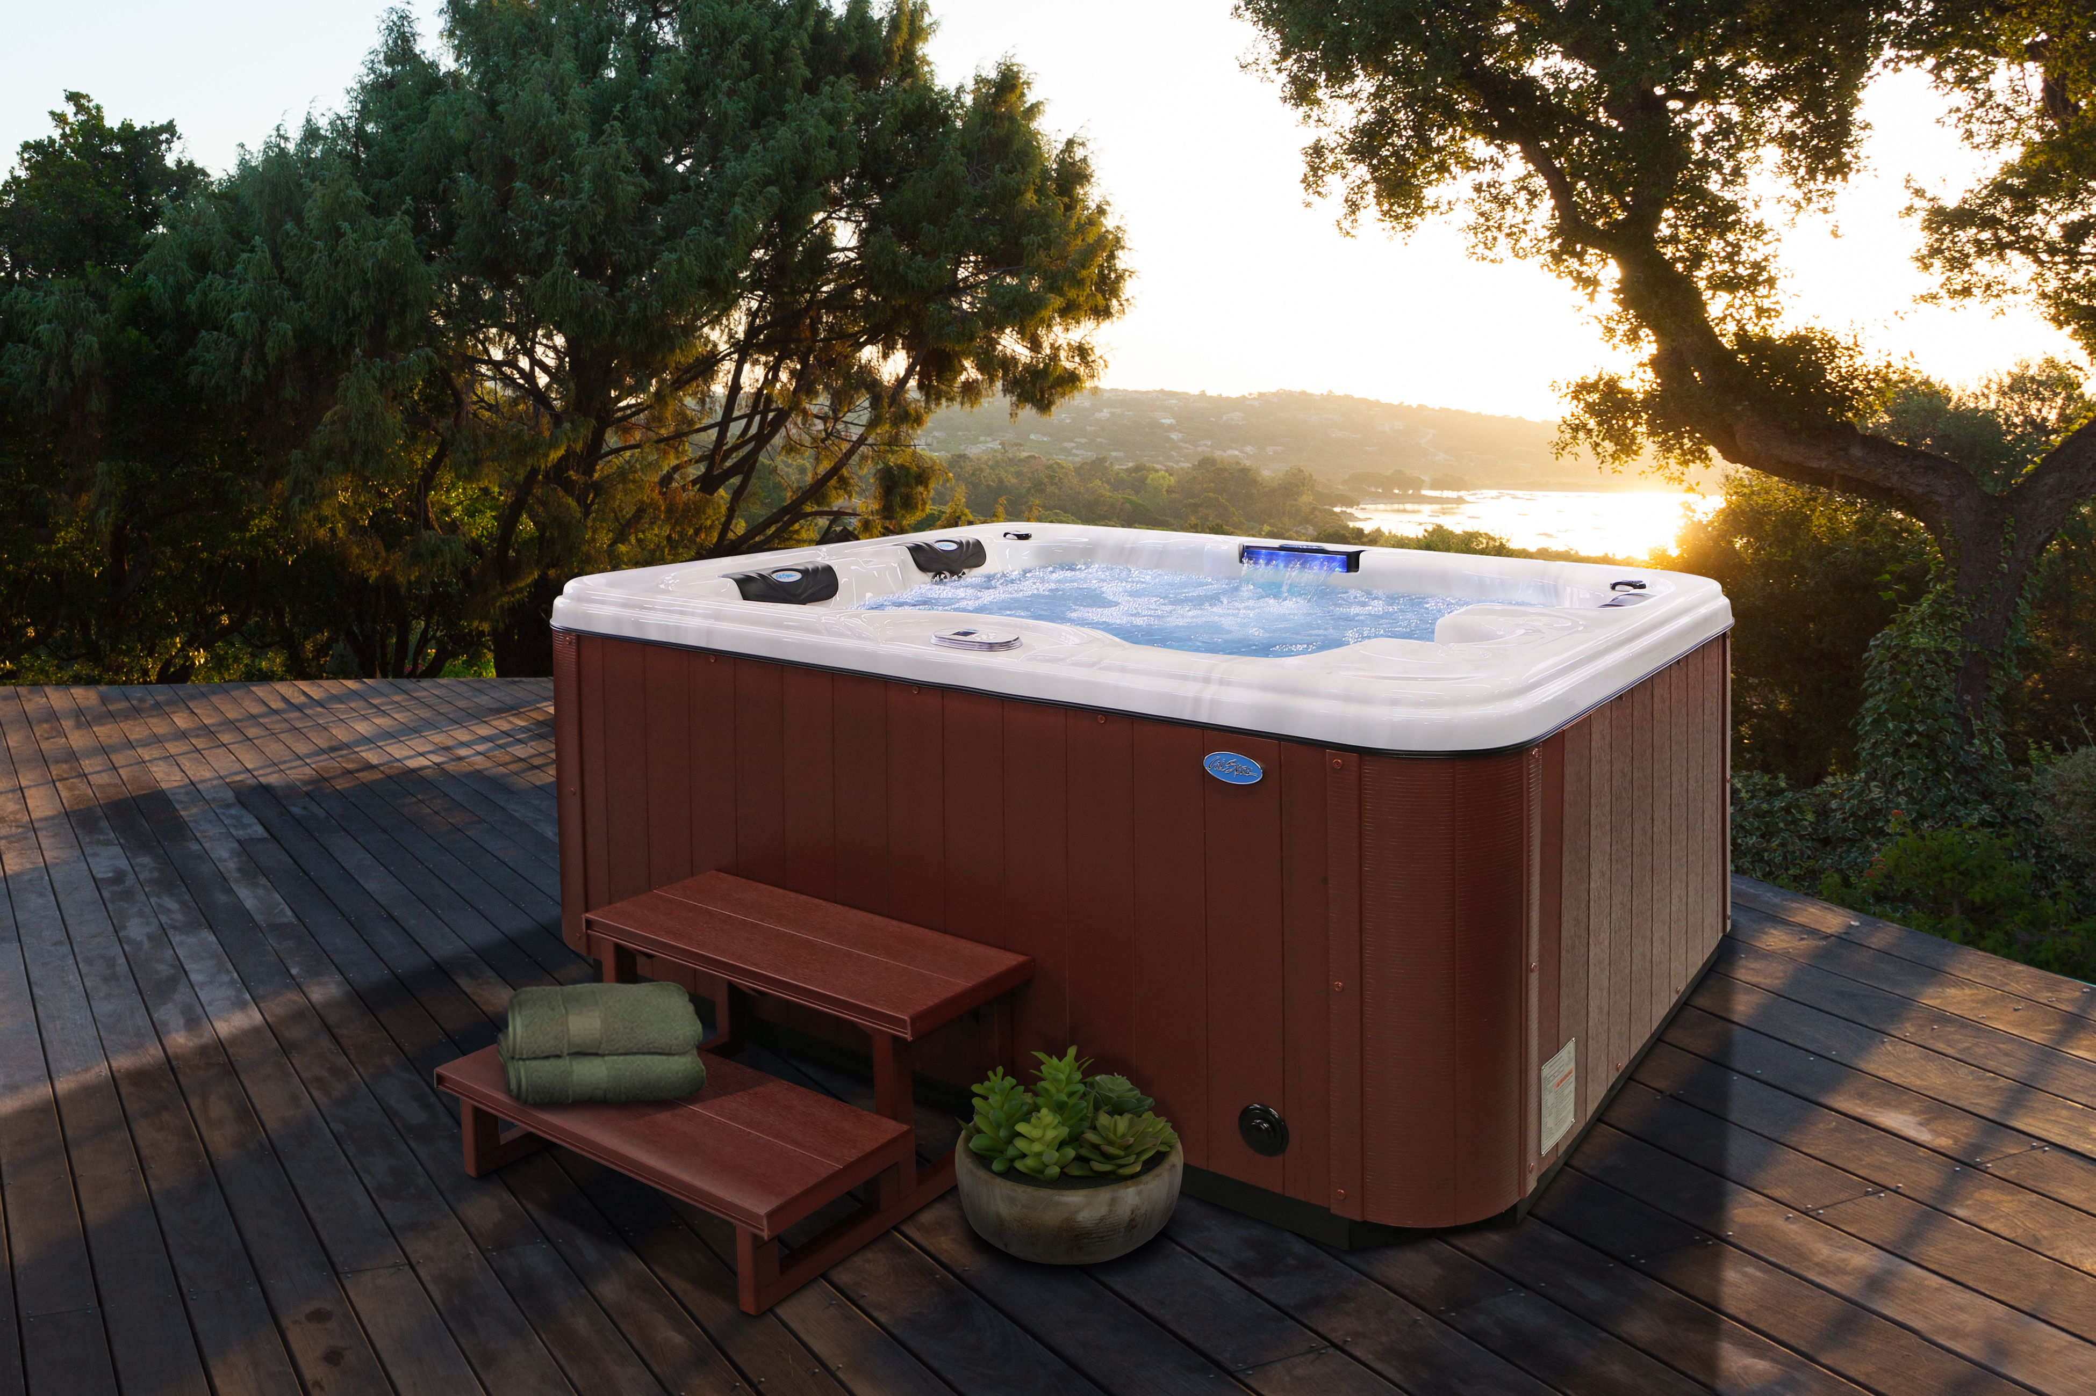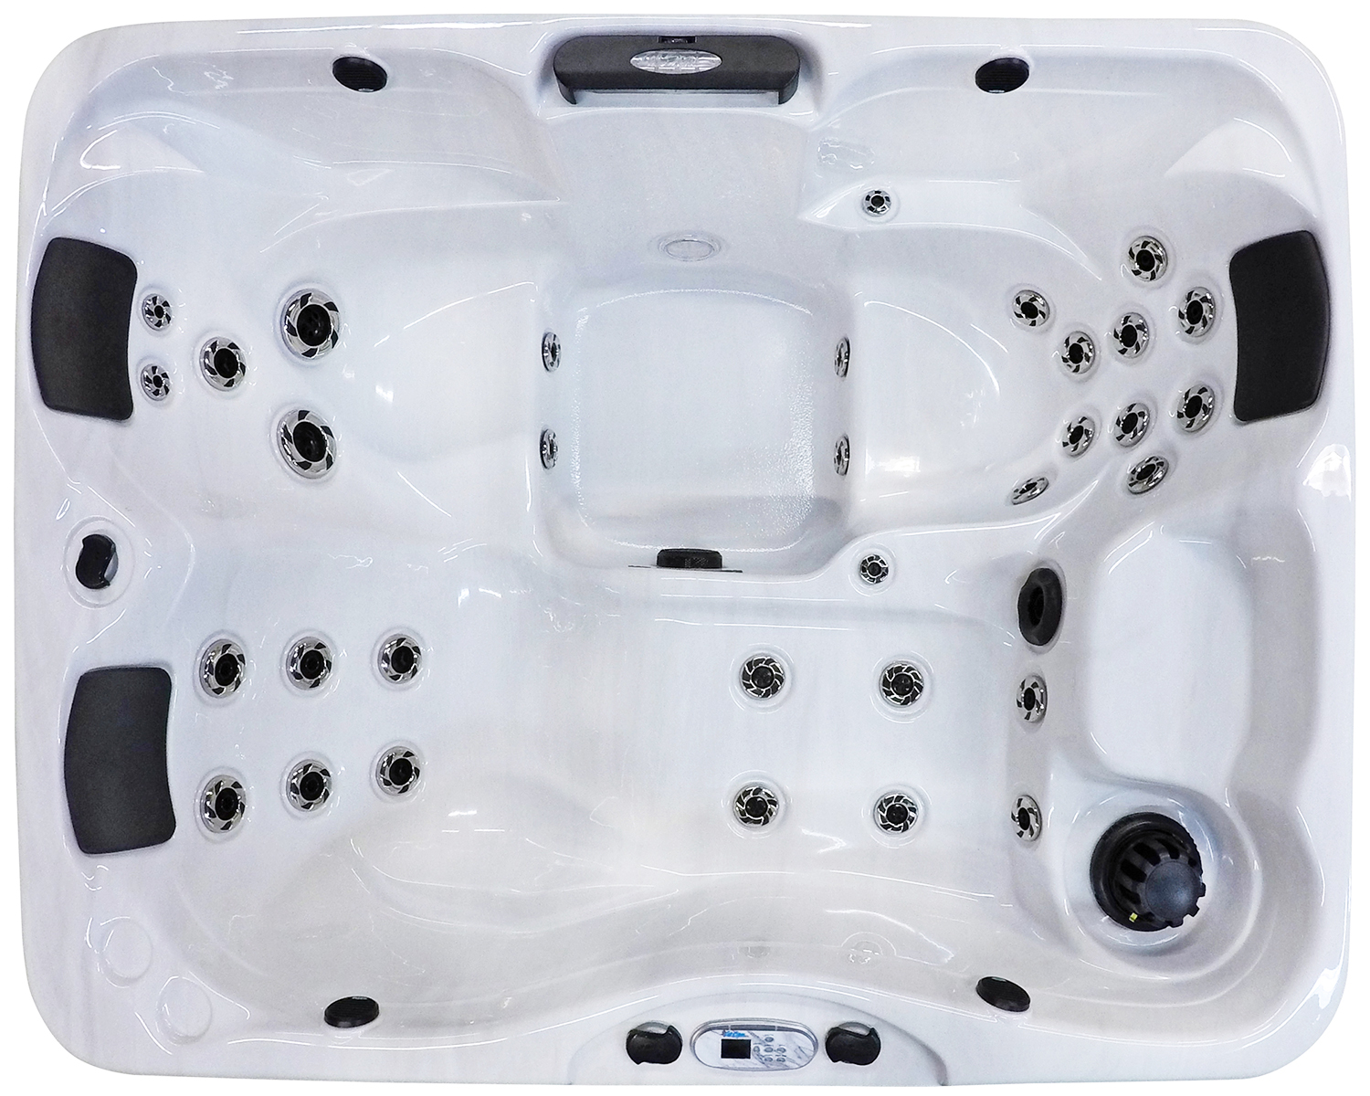  Related Links  Cal Spas Website | Small Tub brings Maximum Hydrotherapy!  Pomona, CA — (October 15, 2018) Sleek and powerful is the newly redesigned Kona. The new update to the Patio Kona PPZ-534L has allowed us to create a larger interior as well as a shorter profile to enter and exit the tub easier. The Kona PPZ-534L is ideal for baby boomers, empty nesters, and singles. People who love the Kona take pride in their own health and wellness. This tub may be on the small side but the hydrotherapy is more powerful than ever.  The total footprint of this spa is 64”x84”x34” and can comfortably fit up to 4 people. With a Sterling Silver Acrylic Shell the Kona has a total of 34 Exclusive Stainless Steel Candy Cane Jets including 1 Turbo Diverter Whirlpool Jet.  The Kona operates using the Eliminator High Performance Pump with 1x6.0BHP and a 240 Operating Voltage. This spa stays heated using the WhisperHot Heating System with 5.5kW Titanium, therefore it is the most powerful heating system in the industry today.  Intuitively operate a Cal Spas Kona Hot Tub using the Whisper Power UnitTM Full Color Oval Topside Control. Additionally, to keep the Kona clean, the Bio-Clean Filter System comes standard with 50 Sq. Ft.  To add extra ambiance, the Cascade Waterfall is a wonderful feature along with the 5” LED Spa Lighting. Additionally, this spa comes with (3) Y-Pillows.  Built to last using Pressure Treated Cabinet Frame and Cal Preferred™ Vertical panels (Mahogany, Smoke & Mist) with premium badge. The standard spa cover is 4” to 2.5” and is available in Gray or Slate.  The Kona is made best to suit your hydrotherapy needs, however if you would like to add enhancements the best optional features for the Kona are the Deluxe Shell Upgrade, Perimeter + Waterfall LED Lighting Package, 24/7 Filteration, Wi-fi, and the Freedom Sound System.  ABOUT CAL SPAS ® Cal Spas was founded in 1978 as a provider of luxury hot tubs. Today, the celebrated hot tub giant is world renowned as the #1 Global Manufacturer of Home Resort Products™. The company produces premium collections of lifestyle products from its headquarters in Pomona, California and distributes worldwide through a network of specialty dealers. The Cal Spas brand family of products includes Cal Spas hot tubs and swim spas and Cal Flame high-end barbecue grills, outdoor barbecue islands, outdoor fireplaces and fire pits. Learn about Home Resort Living and find a local authorized dealer at www.calspas.com.

