NEWS RELEASE
FOR IMMEDIATE RELEASE

MEDIA CONTACT:
Denai Rosen, Public Relations
press@calspas.com or 1-800-CAL-SPAS
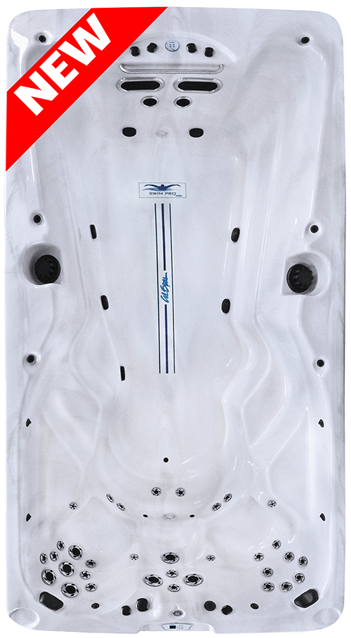  Related Links  Cal Spas Website | Introducing Fitness-Pro 1537  Pomona, CA — (April 3, 2018) Our latest innovation is your solution for a healthier lifestyle. Introducing the Fitness-Pro-1537 including sterling silver acrylic shell with 33 Exclusive Stainless Steel Candy Cane Jets and 4 Swim Jets.  Your limit is your endurance with the Pro-TrainerTM, customize your work out by setting the resistance from 1% to 100% and anywhere in-between. Program your session up to ten different swim resistance and duration settings.  In addition to swimming, you have three seat options behind you. Two captain seats, and one seat that will sit straight up. These jets will give you a deep tissue message. You can also find calf and foot jets so you will be rejuvenated from head to toe after your work out.  This model also comes with a 9” Stainless Steel Exercise Bar, Fitness Anchors, and Tether Anchors for additional exercise options. You can use these tools to do rowing exercises, bicep building and more.  Our Swim Pro Fitness Spas now include a total of eight models, all to suit your fitness life style needs. Large enough to entertain with all the tools to stay fit.  [more]  ABOUT CAL SPAS ®  Cal Spas was founded in 1978 as a provider of luxury hot tubs. Today, the celebrated hot tub giant is world renowned as the #1 Global Manufacturer of Home Resort Products™. The company produces premium collections of lifestyle products from its headquarters in Pomona, California and distributes worldwide through a network of specialty dealers. The Cal Spas brand family of products includes Cal Spas hot tubs and swim spas, Cal Designs gazebos, Cal Heat indoor and outdoor saunas, and Cal Flame high-end barbecue grills, outdoor barbecue islands, outdoor fireplaces and fire pits. Learn about Home Resort Living and find a local authorized dealer at www.calspas.com.

