NEWS RELEASE
FOR IMMEDIATE RELEASE

MEDIA CONTACT:
Denai Rosen, Public Relations

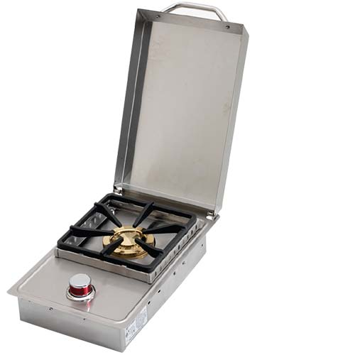  Related Links  Cal Spas Website  Cal Flame Website | Add a Range of Functionality with Cal Flame Side Burners  Pomona, CA — (January 28, 2019) Cal Flame offers a variety of side burners that you can choose to add a Cal Flame outdoor kitchen island. The side burners are great to prepare savory side dishes with your delicious BBQ meal.  Cal Flame Side burners offer the functionality of range to your outdoor kitchen island. It is great for an additional source of heat for cooking. Made with 430 Grade Stainless Stee,l and a total output of 15,000 BTUs, per burner.  Cal Flame offers the following styles of Cal Flame Side Burners:  - Deluxe Double Side by Side Burner  - Standard Side by Side Flat Burner  - Deluxe Double Side Burner  - Standard Single Flat Burner  Each Side Burner comes equipped with a removable cover and one-piece handle. Choose to enjoy Wok cooking in the convenience of your personal BBQ Kitchen.  The convenience of a side burner makes cooking a wholesome meal easier. Cook soups, stews, and skillet dishes without having to quickly run inside your home. Choose a single or double side burner in the style that suits any backyard design.  ABOUT CAL FLAME ®  Founded in 2000, Cal Flame is an award-winning hearth and barbecue manufacturer that offers innovative backyard solutions for every home and budget. Cal Flame lineup includes grills, drop-in accessories, customized outdoor kitchens, barbecue islands, custom barbecue carts, fireplaces and fire pits. For more information about Cal Flame, visit www.calflamebbq.com.

