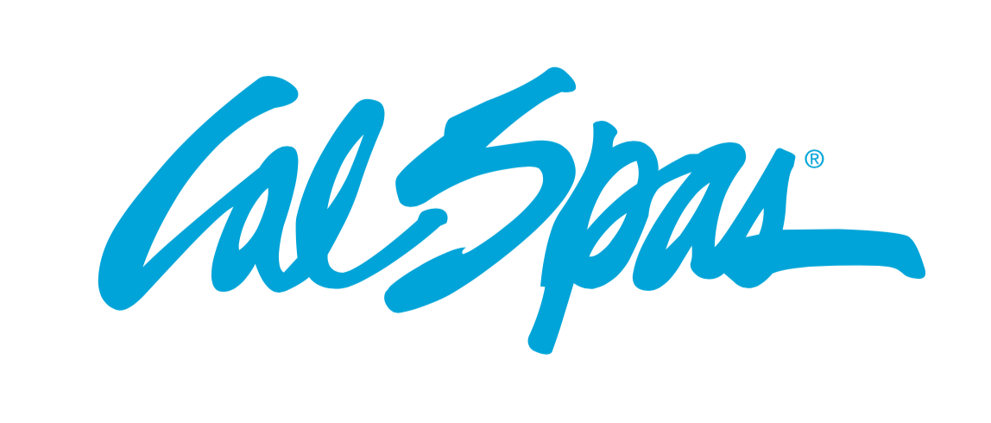
NEWS RELEASE
FOR IMMEDIATE RELEASE

MEDIA CONTACT:
Denai Rosen, Public Relations
press@calspas.com or 1-800-CAL-SPAS
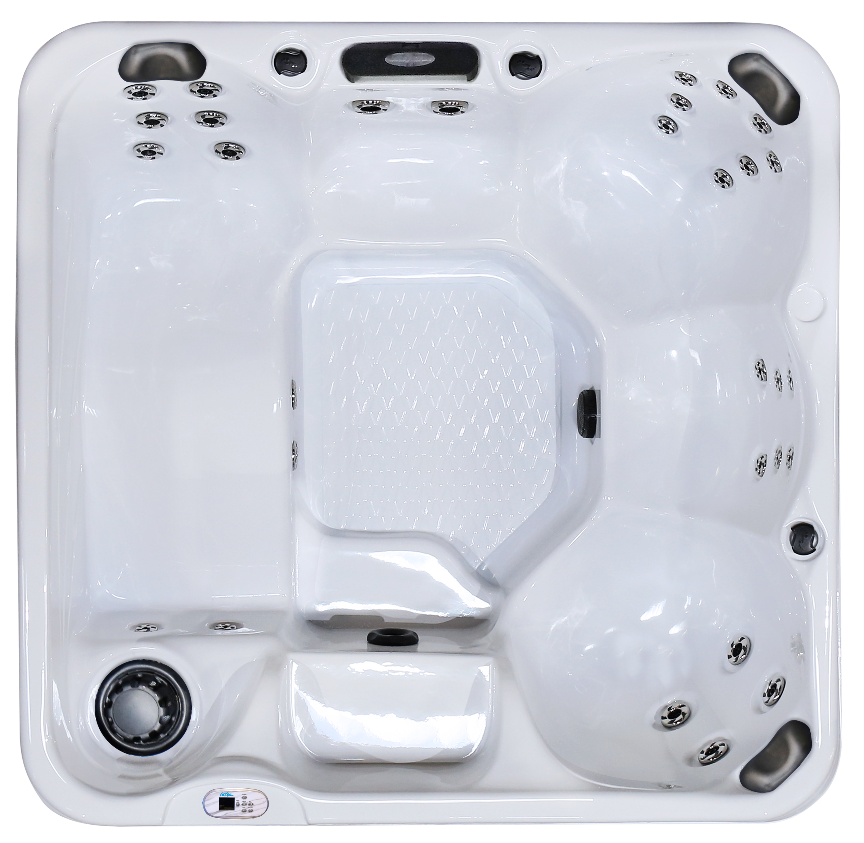  Related Links  Cal Spas Website | Immerse in the Brand New Hawaiian PZ-621L  Pomona, CA — (January 21, 2019) We have just released a brand new mold for the Hawaiian PZ-621L. Coming equipped with ideal seating, strategic jet placement, and exclusive features. The Hawaiian PZ-621L is a 6.5-foot spa with 20 Candy Cane Jets and 1 Turbo Diverter Whirlpool Jet.  The PZ-621L fits up to 6 people with one full sized lounger, bench seating, and  (3) I-pillows. For the perfect ambiance, the PZ-621L comes equipped with a cascade waterfall and a 5” multi-colored LED spa light. Control the spa with a cutting-edge, fully intuitive, LED Smart Control.  The PZ-621L is built using the Whisper Power Unit Heating System that utilizes a 5.5kW Titanium Heater. Keeping the PZ-621L the perfect temperature each and every time. Cal Spas uses specialized technology called Thermo-SheildTM, which is insulated side panels including Thermo-Layer Floor with ABS liner.  Choose to add the Cal Spas Exclusive ATS Plus system. This one-of-a-kind feature will turn the spa into a 2-pump system with a designated therapy seat that allows the consumers to change the seat to 9 different hydrotherapy modes with-in arms reach.  The PZ-621L is a modern and sleek spa that gives you everything you need to benefit from a hydrotherapy session. Consumers may choose from many options to upgrade their spa including the Adjustable Therapy SystemTM Plus (ATS Plus), Fountain of Youth, C-Light, Cal Spas Wi-Fi and more!  ABOUT CAL SPAS ® Cal Spas was founded in 1978 as a provider of luxury hot tubs. Today, the celebrated hot tub giant is world renowned as the #1 Global Manufacturer of Home Resort Products™. The company produces premium collections of lifestyle products from its headquarters in Pomona, California and distributes worldwide through a network of specialty dealers. The Cal Spas brand family of products includes Cal Spas hot tubs and swim spas and Cal Flame high-end barbecue grills, outdoor barbecue islands, outdoor fireplaces and fire pits. Learn about Home Resort Living and find a local authorized dealer at www.calspas.com.

