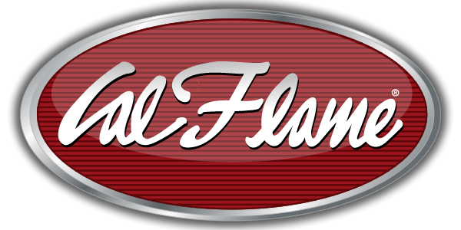
NEWS RELEASE
FOR IMMEDIATE RELEASE

MEDIA CONTACT:
Denai Rosen, Public Relations

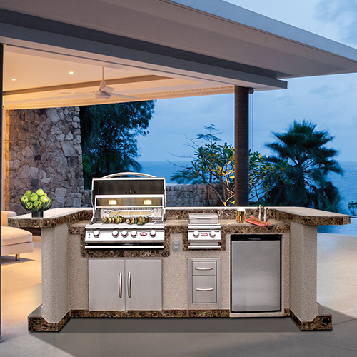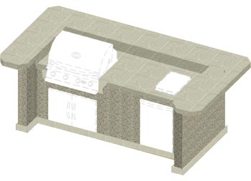  Related Links  Cal Spas Website  Cal Flame Website | Full Bar On a Huge Island is How We Grill!  Pomona, CA — (September 4, 2018) Customize the Cal Flame PV7000 to any flavor for your customer. Coming standard or fully loaded with many options to suit each oasis. The PV7000 is a 6 Foot BBQ Island with the dimensions of 126” x 44” x 51.75” and constructed with a sturdy metal frame that is constructed from Commercial-Grade 16-Gauge Galvanized Steel. Adding additional durability and moisture resistance, the PV7000 Island is dressed in a Hardibacker ceramic tile backer board.  The U-Shaped Island seats 8 – 10 people comfortably, and can be customized with a variety of unique features including 4 or 5 Burner Grills, Deluxe Double Side by Side Burners, LED Lighting, Under Counter Lights, Bluetooth Sound System w/ Speakers, Beer Tap Refrigerator, Ice Maker, Hibachi Drop in Grill, Stainless Steel Sink with Faucet, Propane Tank Drawer, and many other exciting features that are available. The island comes standard with Interior and Exterior Electrical.  The PV7000 has choices of finishes including Durable Porcelain Tile or Natural Stone Tile countertop colors. Paired with AmeriStone Stucco or Cultured Stone base designs which can be combined to best match your overall outdoor setting.  Cal Flame offers fully customizable Luxury BBQ Island such as the PV7000 with many styling options to choose from and features to choose from. Other features to choose from is LED Lighting, Under counter Lights, Freedom™ Sound System Bluetooth, Powered Subwoofer and 2 Speakers, and an Umbrella Hole.  Cal Flame brings luxury to the table. It will be easy to impress friends and family each and every occasion by bringing people together around the Cal Flame PV7000 for wholesome grilling and good company.  ABOUT CAL FLAME ® Founded in 2000, Cal Flame is an  award-winning hearth and barbecue manufacturer that offers innovative backyard solutions for every home and budget. Cal Flame lineup includes grills, drop-in accessories, customized outdoor kitchens, barbecue islands, custom barbecue carts, fireplaces and fire pits. For more information about Cal Flame, visit www.calflamebbq.com.

