NEWS RELEASE
FOR IMMEDIATE RELEASE

MEDIA CONTACT:
Denai Rosen, Public Relations
press@calspas.com or 1-800-CAL-SPAS
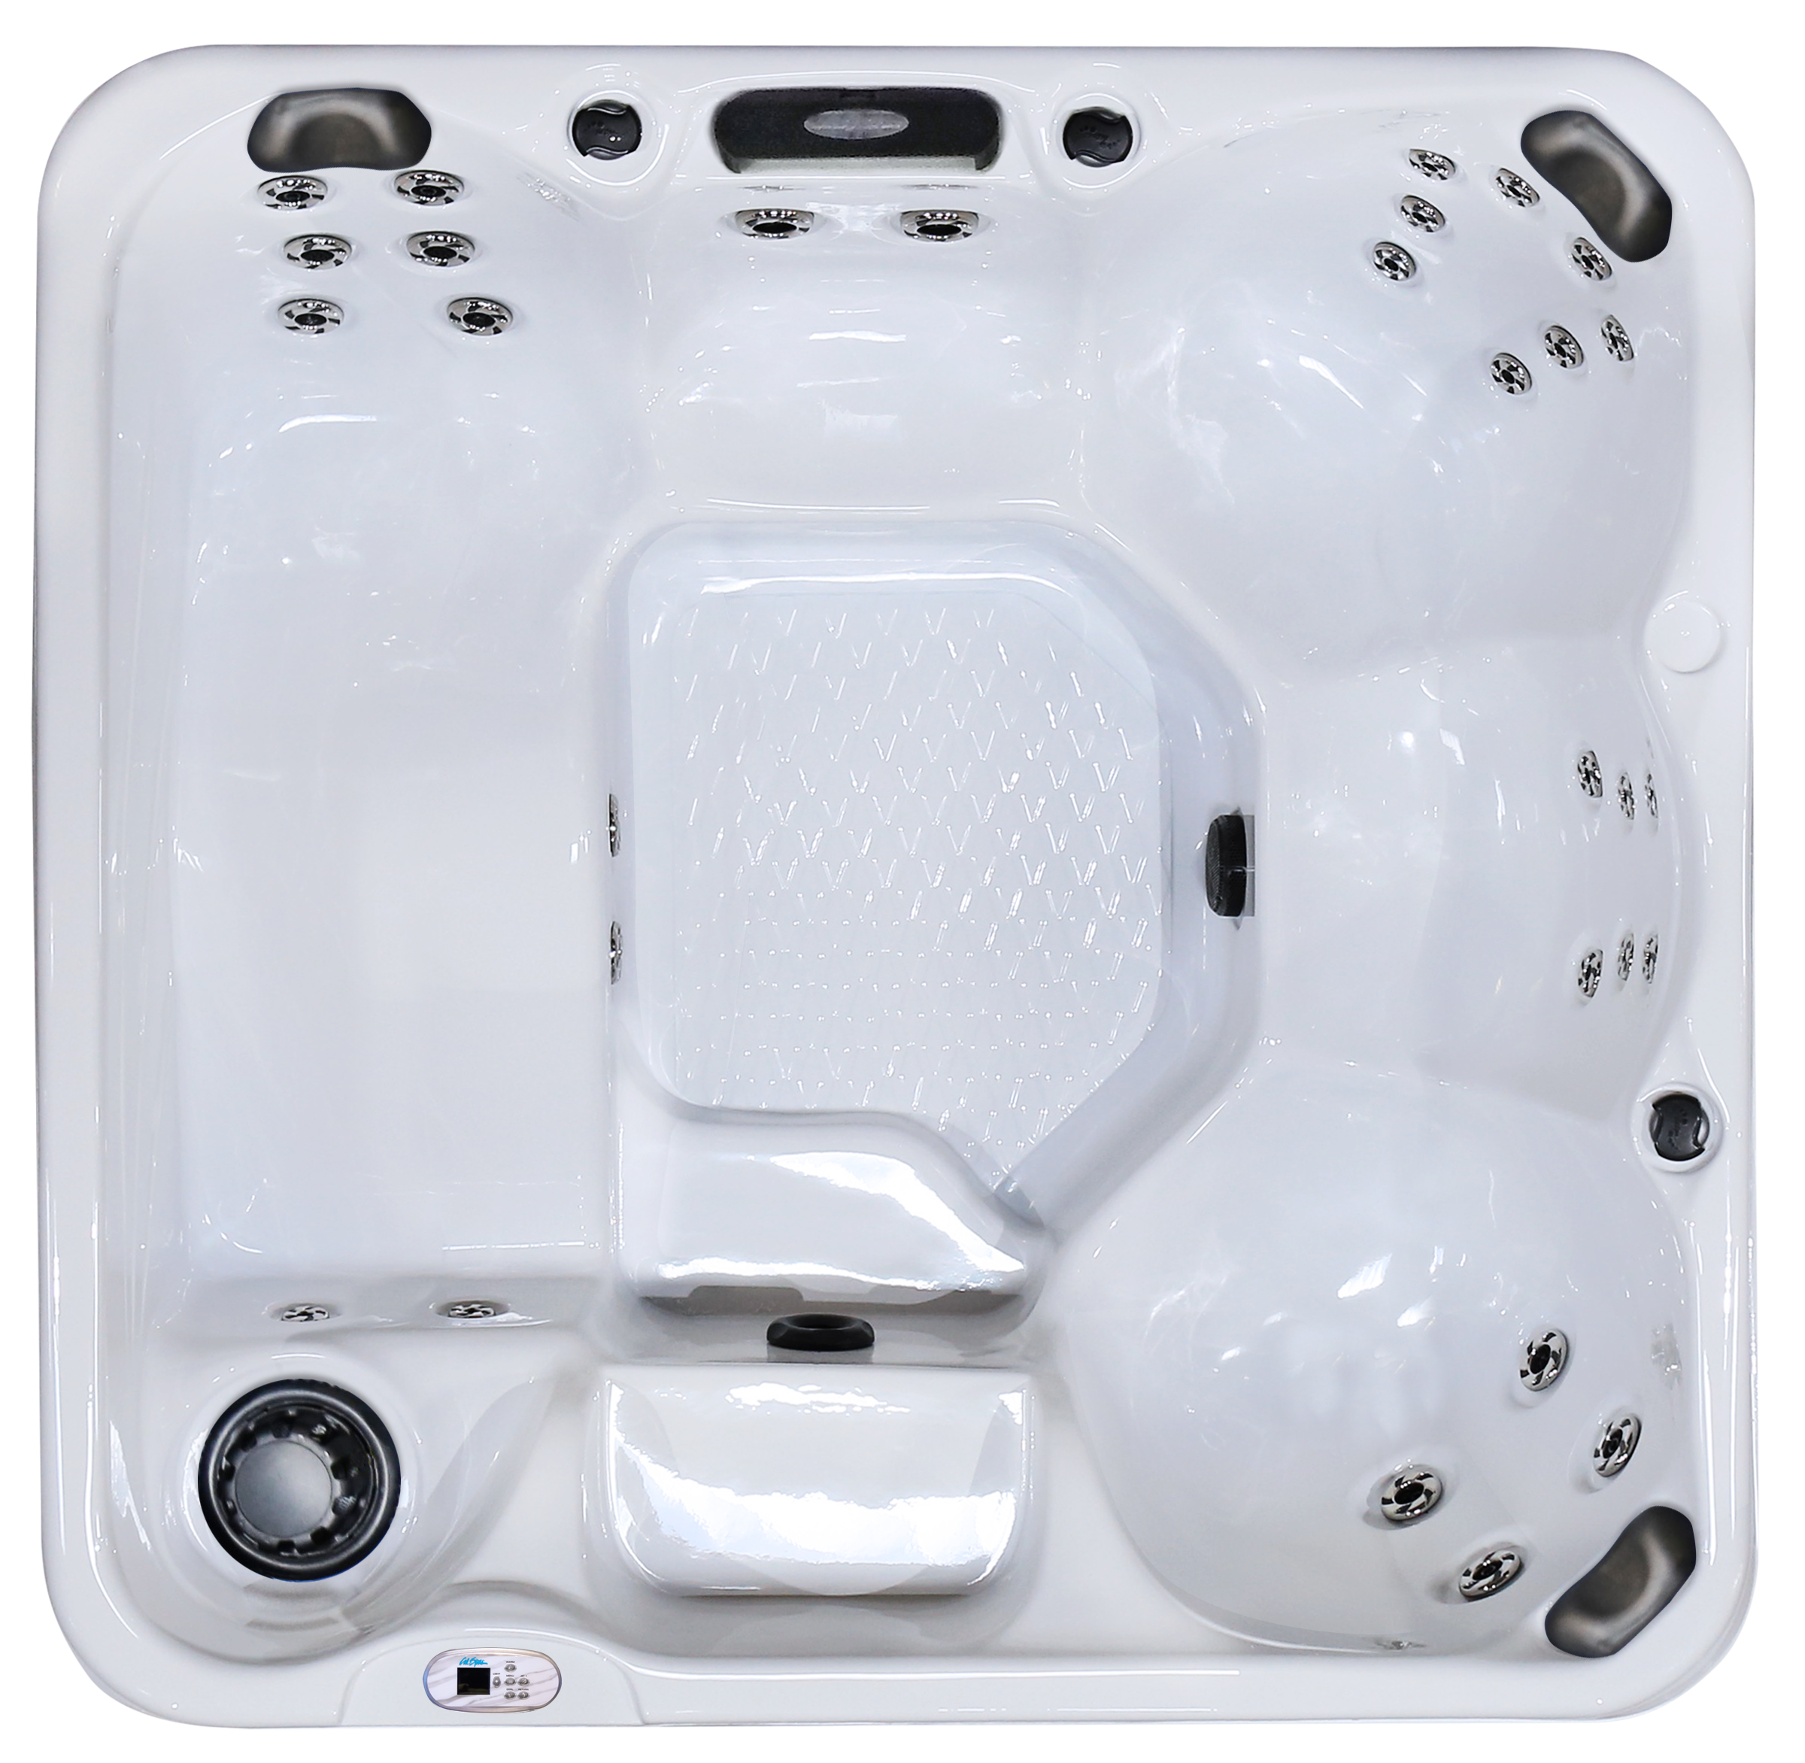  Related Links  Cal Spas Website | Release of the Hawaiian Plus PPZ-631L  Pomona, CA — (January 8, 2019) We are constantly and consistently innovating to bring you the best luxury item on the market today. We are proud to share with you a new mold in the Cal Spas Patio Plus product line. The Hawaiian Plus PPZ-631L is a 6.5-foot spa with 30 Candy Cane Jets and 1 Turbo Diverter Whirlpool Jet.  The PPZ-631L fits up to 6 people and includes one full sized lounger. To add extra stimulation to your senses, the PPZ-631L comes equipped with a cascade waterfall and a 5” multi-colored LED spa light. For comfort, this spa comes with (3) I-Pillows. Easily control the spa with a fully intuitive LED Oval Topside Control.  The Whisper Power Unit Heating System utilizes a 5.5kW Titanium Heater, which keeps the PPZ-631L the perfect temperature each and every time. Built with Thermo-SheildTM Insulation side panels and Thermo-Layer Floor with ABS liner.  Dress up the PPZ-631L in style with Cal Spas Exclusive ATS Plus system. This unique optional feature will turn the spa into a 2-pump system with a designated therapy seat that has 9 different adjustable hydrotherapy options at the consumer’s fingertips!  The PPZ-631L is a wonderfully designed spa that comes with standard features that offer everything you need to give you the best hydrotherapy experience. We have many upgraded features you can choose to from including the Adjustable Therapy SystemTM Plus (ATS Plus), Fountain of Youth, C-Light, Cal Spas Wi-Fi and more!  ABOUT CAL SPAS ® Cal Spas was founded in 1978 as a provider of luxury hot tubs. Today, the celebrated hot tub giant is world renowned as the #1 Global Manufacturer of Home Resort Products™. The company produces premium collections of lifestyle products from its headquarters in Pomona, California and distributes worldwide through a network of specialty dealers. The Cal Spas brand family of products includes Cal Spas hot tubs and swim spas and Cal Flame high-end barbecue grills, outdoor barbecue islands, outdoor fireplaces and fire pits. Learn about Home Resort Living and find a local authorized dealer at www.calspas.com.

