NEWS RELEASE
FOR IMMEDIATE RELEASE

MEDIA CONTACT:
Denai Rosen, Public Relations
press@calspas.com or 1-800-CAL-SPAS

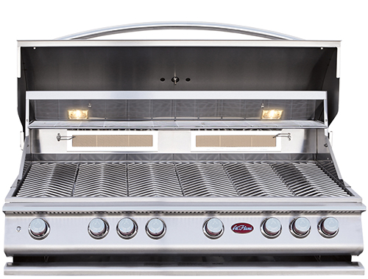  Related Links  Cal Spas Website  Cal Flame Website | The P6 is Just The Right Size for Large Gatherings  Pomona, CA — (November 5, 2018) Feast your eyes on a large grilling surface of 1,100 sq. in. with a total output of 110,000 BTU including  6 burners and 2 infrared back burners.  The P6 is patented technology made with:  - 304-Stainless Steel, 2-Layer Welded, Construction  - One Piece Heavy Duty Handle  - Cast Stainless Steel Knobs  - Independent Burner Ignition System  - Vented Knob Splash Guards  - Removable Heavy-Duty Grates with V-Grate Cooking Design  - Dual Halogen Interior Lights  - Built-In Temperature Gauge  - Light Switch with LED Bezel  - Full-Width Warming Rack  The P6 is a beautifully constructed heavy-duty grill that comes with a Rotisserie and adjustable motor mount. It also includes full width Stainless Steel Drip Tray on rollers, which makes cleaning very easy.  The P6 offers everything you need to make a gourmet meal. When you get the P6 you are also getting a smoker box to enhance a smoke flavor to your food. The griddle tray also comes standard and is a great accessory to cook eggs, bacon and other food items. Keep the P6 protected from the great outdoors with the Cal Flame Grill Cover that also comes standard with the P6.  The P6 is the largest grill you can find for parties and special occasions. If you would like to add Cal Flame Drop-In Accessories, the P6 will accommodate the Deep Fryer Set, Rotisserie Basket, Sear Zone Burner, Charcoal Tray and more.  [more]  ABOUT CAL FLAME ® Founded in 2000, Cal Flame is an award-winning hearth and barbecue manufacturer that offers innovative backyard solutions for every home and budget. Cal Flame lineup includes grills, drop-in accessories, customized outdoor kitchens, barbecue islands, custom barbecue carts, fireplaces and fire pits. For more information about Cal Flame, visit www.calflamebbq.com.

