NEWS RELEASE
FOR IMMEDIATE RELEASE

MEDIA CONTACT:
Denai Rosen, Public Relations
press@calspas.com or 1-800-CAL-SPAS

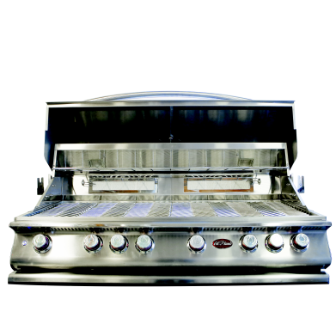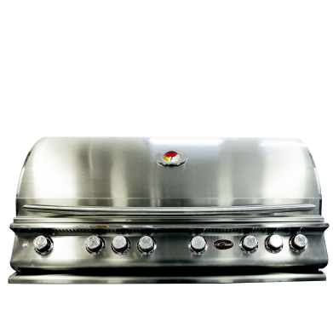  Related Links  Cal Spas Website  Cal Flame Website | Biggest & Baddest Grill You Have Ever Grilled On!  Pomona, CA — (April 25, 2018) We have discovered many great benefits to cooking meals on a grill, and if you have a large family, you will want a large grill. The P6 is the perfect solution for entertaining guests and feeding your family. When purchasing a P series P6 grill you will also get a grill cover, rotisserie including 110v motor, griddle tray, and smoke tray.  The P6 is the ultimate chef’s dream! Made with commercial-grade materials and contemporary design with double walled welded structure and polished stainless steel finish. It has a total of 112,000 BTU output with 6 burners and 2 infrared burners. All parts are dishwasher friendly and easy to clean.  You have never seen a grill this size with so many perks. Protect your grill from weather damage using our P-Grill Cover that is included. Additionally, cook your meat perfectly with our motorized Rotisserie; this configuration spins itself! Furthermore, have you ever heard of cooking breakfast on your grill? Now you can make that happen. Enjoy all the breakfast classics such as bacon, eggs, and pancakes on our  P-Griddle tray. Oh and food has never taste so good since the P6 comes with a P-Smoke Tray; infuse your BBQ with a smoky flavor!  You can always find a great meal to grill for your friends and family using the P6. With a carefully thought out design, we have launched our latest innovation so you can grill using top of the line products.  Customers are encouraged to visit their local certified  Cal Flame BBQ dealer to find more information about the  Premium 6 including pricing, availability and customization.  ABOUT CAL FLAME ® Founded in 2000, Cal Flame is an  award-winning hearth and barbecue manufacturer that offers innovative backyard solutions for every home and budget. Cal Flame lineup includes grills, drop-in accessories, customized outdoor kitchens, barbecue islands, custom barbecue carts, fireplaces and fire pits. For more information about Cal Flame, visit www.calflamebbq.com.

