NEWS RELEASE
FOR IMMEDIATE RELEASE

MEDIA CONTACT:
Lauren Roberts, Public Relations
lroberts@calspas.com or 1-800-CAL-SPAS

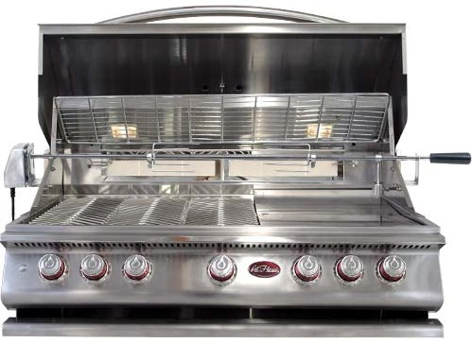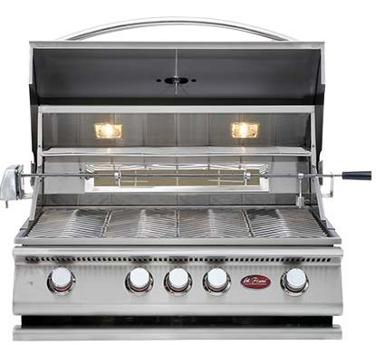 Constructed with 304 Stainless Steel and Stainless Steel Burners, the P Series grills are as durable as they are multi-functional.  Related Links  Cal Spas Website | Cal Flame P Series Grills are Bestsellers  P4 and P5 Grills Continue to Impress  Pomona, CA — (September 19, 2017) Cal Flame BBQ does it again! The renowned hearth and barbecue manufacturer has seen tremendous success with their P Series grills, selling over 5,000 units since the series’ release.  P Series grills come standard with many features and accessories, such as a P-Grill Cover, Rotisserie, P-Griddle Tray, and P-Smoke Tray. These features allow the user to create a vast array of dishes. Constructed with 16-gauge, 304 Stainless Steel and Stainless Steel Burners, the P Series grills are as durable as they are multi-functional.  Each P Series grill is packed with power to deliver the comfort of indoor cooking to any outdoor living space. Double wall insulation is standard to all Cal Flame grills, and it serves two purposes: to protect the user from heat that might otherwise penetrate the hood or handle, and for resilience. The stainless steel will not discolor, or turn blue from heat.  The P Series grills also come equipped with an impressive ignition system. Cal Flame introduced cast stainless steel burner knobs to the grill industry. Each knob instantly ignites the corresponding burner, independently from the other burners. Each burner is designed with a dedicated igniter.  The P Series grills are the perfect solution for any backyard cooking enthusiast, beginner or pro.  [more]  For more information about Cal Spas Swim Pro™ Swim & Fitness Spa please visit the Cal Spas website, or locate a certified dealer in your area.  To schedule an interview with one of Cal Spas industry professionals contact Public Relations Specialist, Lauren Roberts, at 909-620-0480 or lroberts@calspas.com.  ABOUT CAL SPAS ®  Cal Spas was founded in 1979 as a provider of luxury hot tubs. Today, the celebrated hot tub giant is world renowned as the #1 Global Manufacturer of Home Resort Products™. The company produces premium collections of lifestyle products from its headquarters in Pomona, California and distributes worldwide through a network of specialty dealers. The Cal Spas brand family of products includes Cal Spas hot tubs and swim spas, Cal Designs gazebos, Cal Heat indoor and outdoor saunas, and Cal Flame high-end barbecue grills, outdoor barbecue islands, outdoor fireplaces and fire pits. Learn about Home Resort Living and find a local authorized dealer at www.calspas.com.

