NEWS RELEASE

FOR IMMEDIATE RELEASE

MEDIA CONTACT:

Denai Rosen, Public Relations
press@calspas.com or 1-800-CAL-SPAS
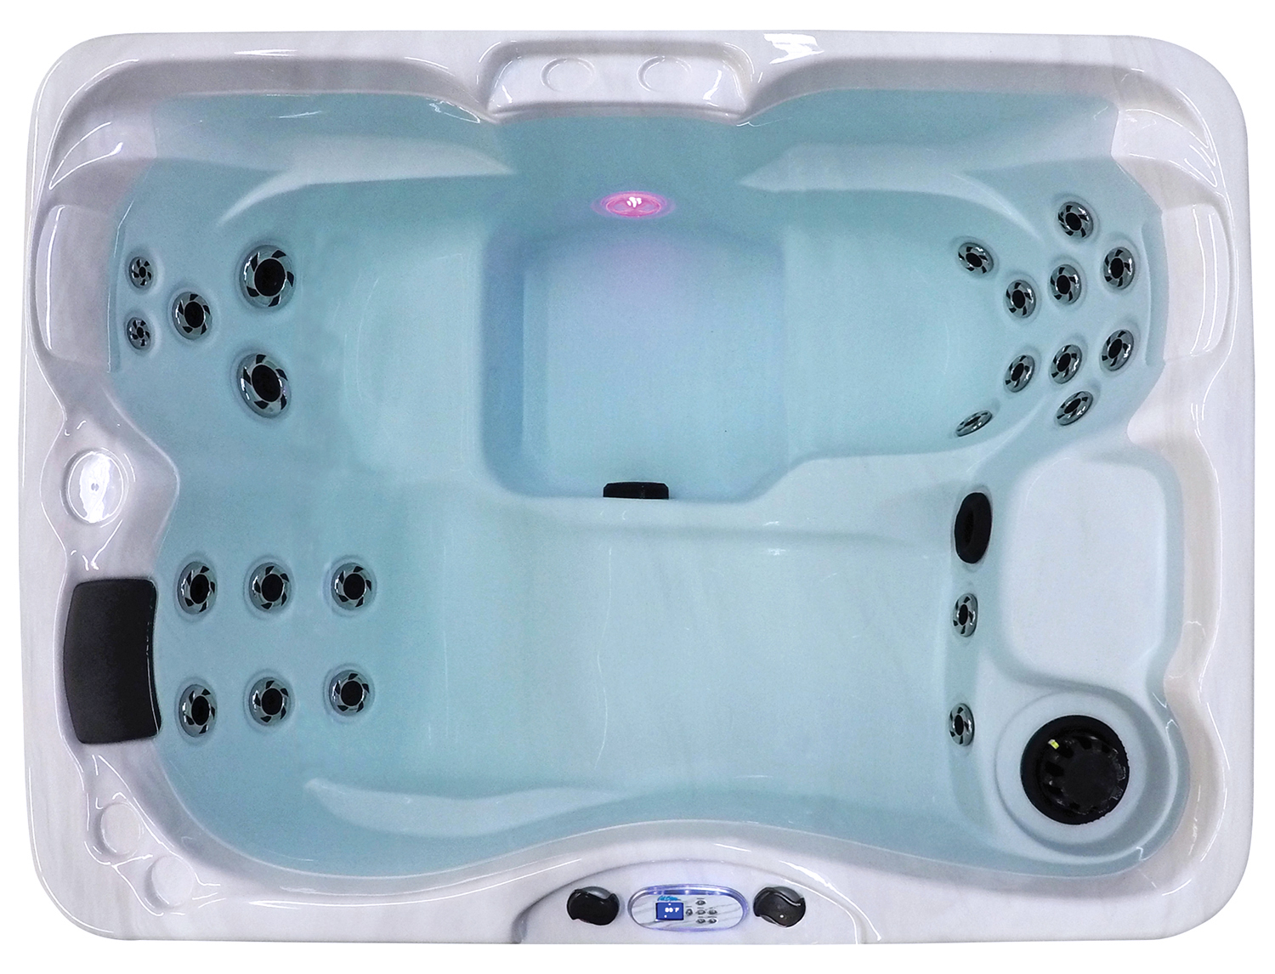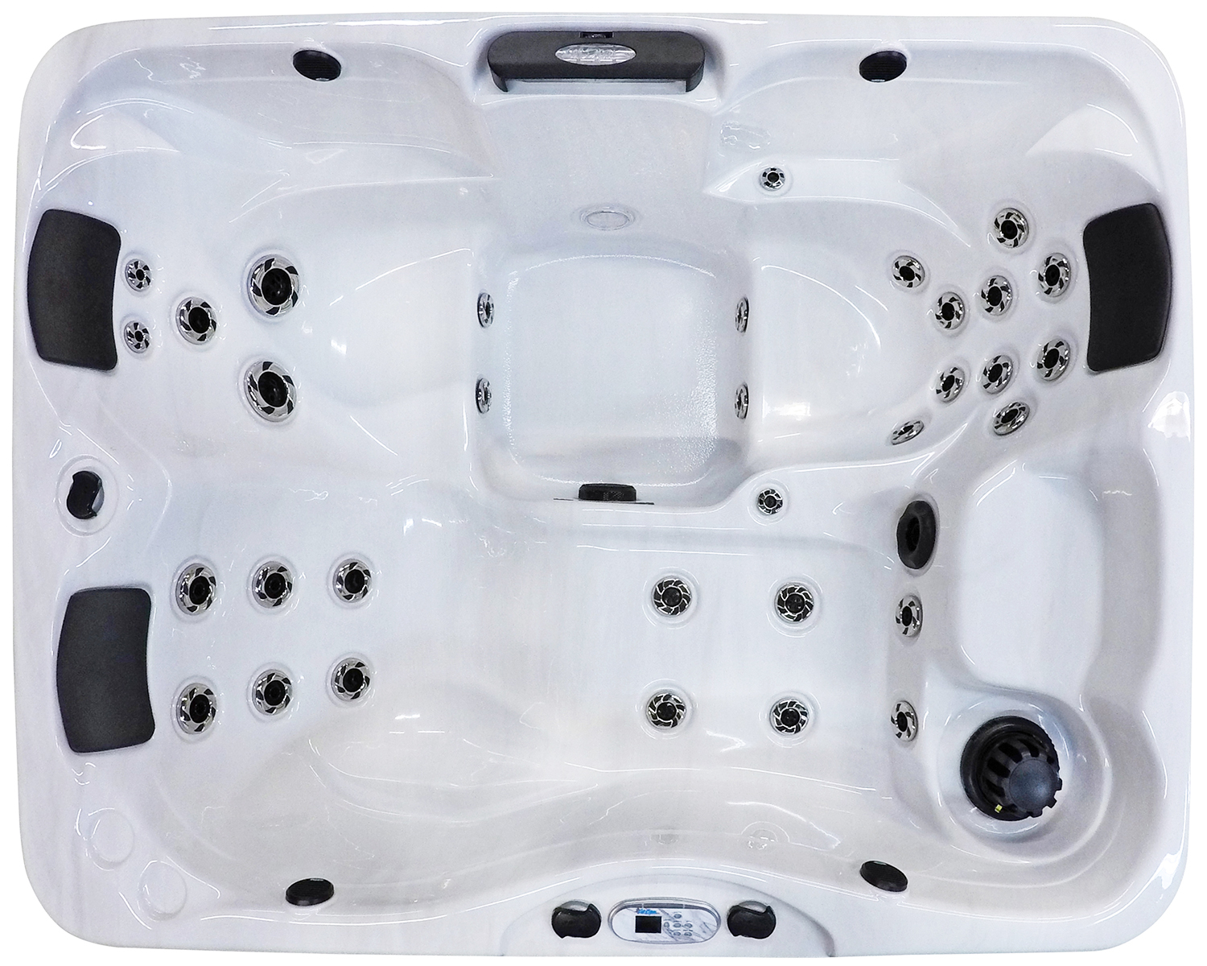  Related Links  Cal Spas Website | New Kona, New Mold, New Model  Pomona, CA — (April 24, 2018) Using cutting-edge components and thoughtful decisions we have re-designed the Kona to be the best 4-person hot tub on the market today.  Including a full-size lounger, and two full-size bench seats that form to fit all body shapes and sizes. With the Kona, we have created a larger footwell for more space for comfort. As a result, you will find new foot jets. When your spa session becomes too hot, reboot yourself in our Kool-Off seat. Cal Spas Kool-Off seat is elevated so you can take a breather but still be in the tub.  Using exclusive Candy Cane Jets you will find new enhanced jet mix and placement that gives you a directional deep tissue massage. Rest your arms on one of our captain seats, and on the Patio Plus Kona, feel the hand jets rejuvenate your arms.  Turn up your night by adding optional features to your Kona! Now available is our FreedomTM Sound System Bluetooth, powered subwoofer, and four speakers. Additionally, add a C-LightTM to the front cabinets to illuminate your backyard. A good option you may want to consider is the 24-hour filtration system, this circulation pump constantly and quietly heats the water, continuously filters heated water, and saves energy by minimizing pump operation.  Giving you the same footprint as the last Kona with a larger interior! Easily get the Kona in and out of your home considering the profile is shorter leaving it at a whopping 32”. With a new shorter profile, you can enter and exit the spa with ease.  ABOUT CAL SPAS ®  Cal Spas was founded in 1978 as a provider of luxury hot tubs. Today, the celebrated hot tub giant is world renowned as the #1 Global Manufacturer of Home Resort Products™. The company produces premium collections of lifestyle products from its headquarters in Pomona, California and distributes worldwide through a network of specialty dealers. The Cal Spas brand family of products includes Cal Spas hot tubs and swim spas, Cal Designs gazebos, Cal Heat indoor and outdoor saunas, and Cal Flame high-end barbecue grills, outdoor barbecue islands, outdoor fireplaces and fire pits. Learn about Home Resort Living and find a local authorized dealer at www.calspas.com.

