NEWS RELEASE
FOR IMMEDIATE RELEASE

MEDIA CONTACT:
Denai Rosen, Public Relations

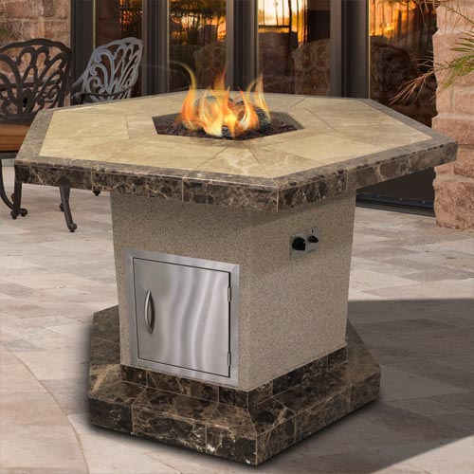  Related Links  Cal Spas Website  Cal Flame Website | Live in Lavish With The Best Fire Pit on the Market  Pomona, CA — (February 11, 2019) Take a look at the FPT-1050T exclusively from Cal Flame, offering functionality and entertainment, which is a true luxury to each household.  The tabletop is a 61” hexagon shape with a height of 45”. The height of the FPT-1050T is the same as a bar. Therefore, anyone can enjoy a meal while watching the fire. A footrest is at the bottom to enhance comfort.  The FPT-1050T is finished with Ameristone Stucco and a 12x12 Porcelain Tile border in various color options to choose from that will compliment any home resort design.  The square firebox has a BTU output of 55,000 and comes equipped with an everlasting 4-piece 16” log set with lava rocks. The FPT-1050T is Liquid Propane standard but can be converted to Natural Gas by using a certified electrician.  The 18’ vertical door comes standard to easily store the propane tank. Never use a match with Cal Flame; all products come with the Piezo and blowtorch system. Just a simple turn and you can light up the night. The FPT-1050T is meant to live in lavish.  _________________________________________________________  ABOUT CAL FLAME ®  Founded in 2000, Cal Flame is an award-winning hearth and barbecue manufacturer that offers innovative backyard solutions for every home and budget. Cal Flame lineup includes grills, drop-in accessories, customized outdoor kitchens, barbecue islands, custom barbecue carts, fireplaces and fire pits. For more information about Cal Flame, visit www.calflamebbq.com.

