NEWS RELEASE
FOR IMMEDIATE RELEASE

MEDIA CONTACT:
Denai Rosen, Public Relations

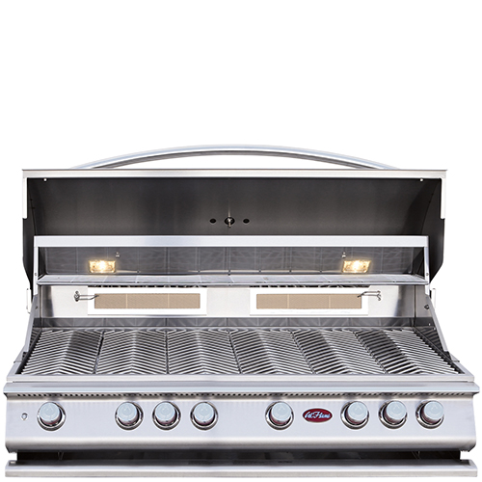  Related Links  Cal Spas Website  Cal Flame Website | The Legendary P6 Cal Flame Grill  Pomona, CA — (August 14, 2018) You see it first on the Cal Flame product line. Introducing our legendary 6-Burner Convection Grill that we call the P6. Built with 304-Stainless Steel Construction that is seamless in design.  The Cal Flame P6 Grill has an ultimate total of 110,000K BTU output with six (6) burners, two (2) infrared burners. The P6 is 1,100 sq. in. cooking surface with removable Heavy-Duty Grate with a V-Grate Cooking Design. Pictures do not do justice with how durable and legitimate the P6 is.  Holding up to 35lbs full-sized rotisseries, including flavor bar seals,  full-width warming racks, large thermometer, drip trays, grill lights, dishwasher-friendly parts. The P6 is legendary!  You do not need a flame to get the P6 started; each burner has its own Independent Ignition System, therefore, we guarantee the P6 will turn on with a simple twist of the wrist, no problems.  Under the hood you will find Dual Halogen Interior Lights. Along with a back burner sear zone, Rotisserie with Adjustable Motor Mount, and a P-Smoker Box and P-Griddle Tray comes standard.  With a strategic design Cal Flame is able to prevent build up with our exclusive Full Width Stainless Steel Drip Tray on Rollers. This allows the P6 to stay clean and functional.  The P6 patented Stainless Steel Knobs are exclusive in design. Vented Knob Splash Guards are located above the knobs so you will never burn your fingers. Next to the knobs you will find the on/off light switch with LED Bezel. Cooking meat to perfection is easy with the P6!  [more]  ABOUT CAL FLAME ® Founded in 2000, Cal Flame is an  award-winning hearth and barbecue manufacturer that offers innovative backyard solutions for every home and budget. Cal Flame lineup includes grills, drop-in accessories, customized outdoor kitchens, barbecue islands, custom barbecue carts, fireplaces and fire pits. For more information about Cal Flame, visit www.calflamebbq.com.

