NEWS RELEASE
FOR IMMEDIATE RELEASE

MEDIA CONTACT:
Denai Rosen, Public Relations
press@calspas.com or 1-800-CAL-SPAS

Related Links  Cal Spas Website  Cal Flame Website  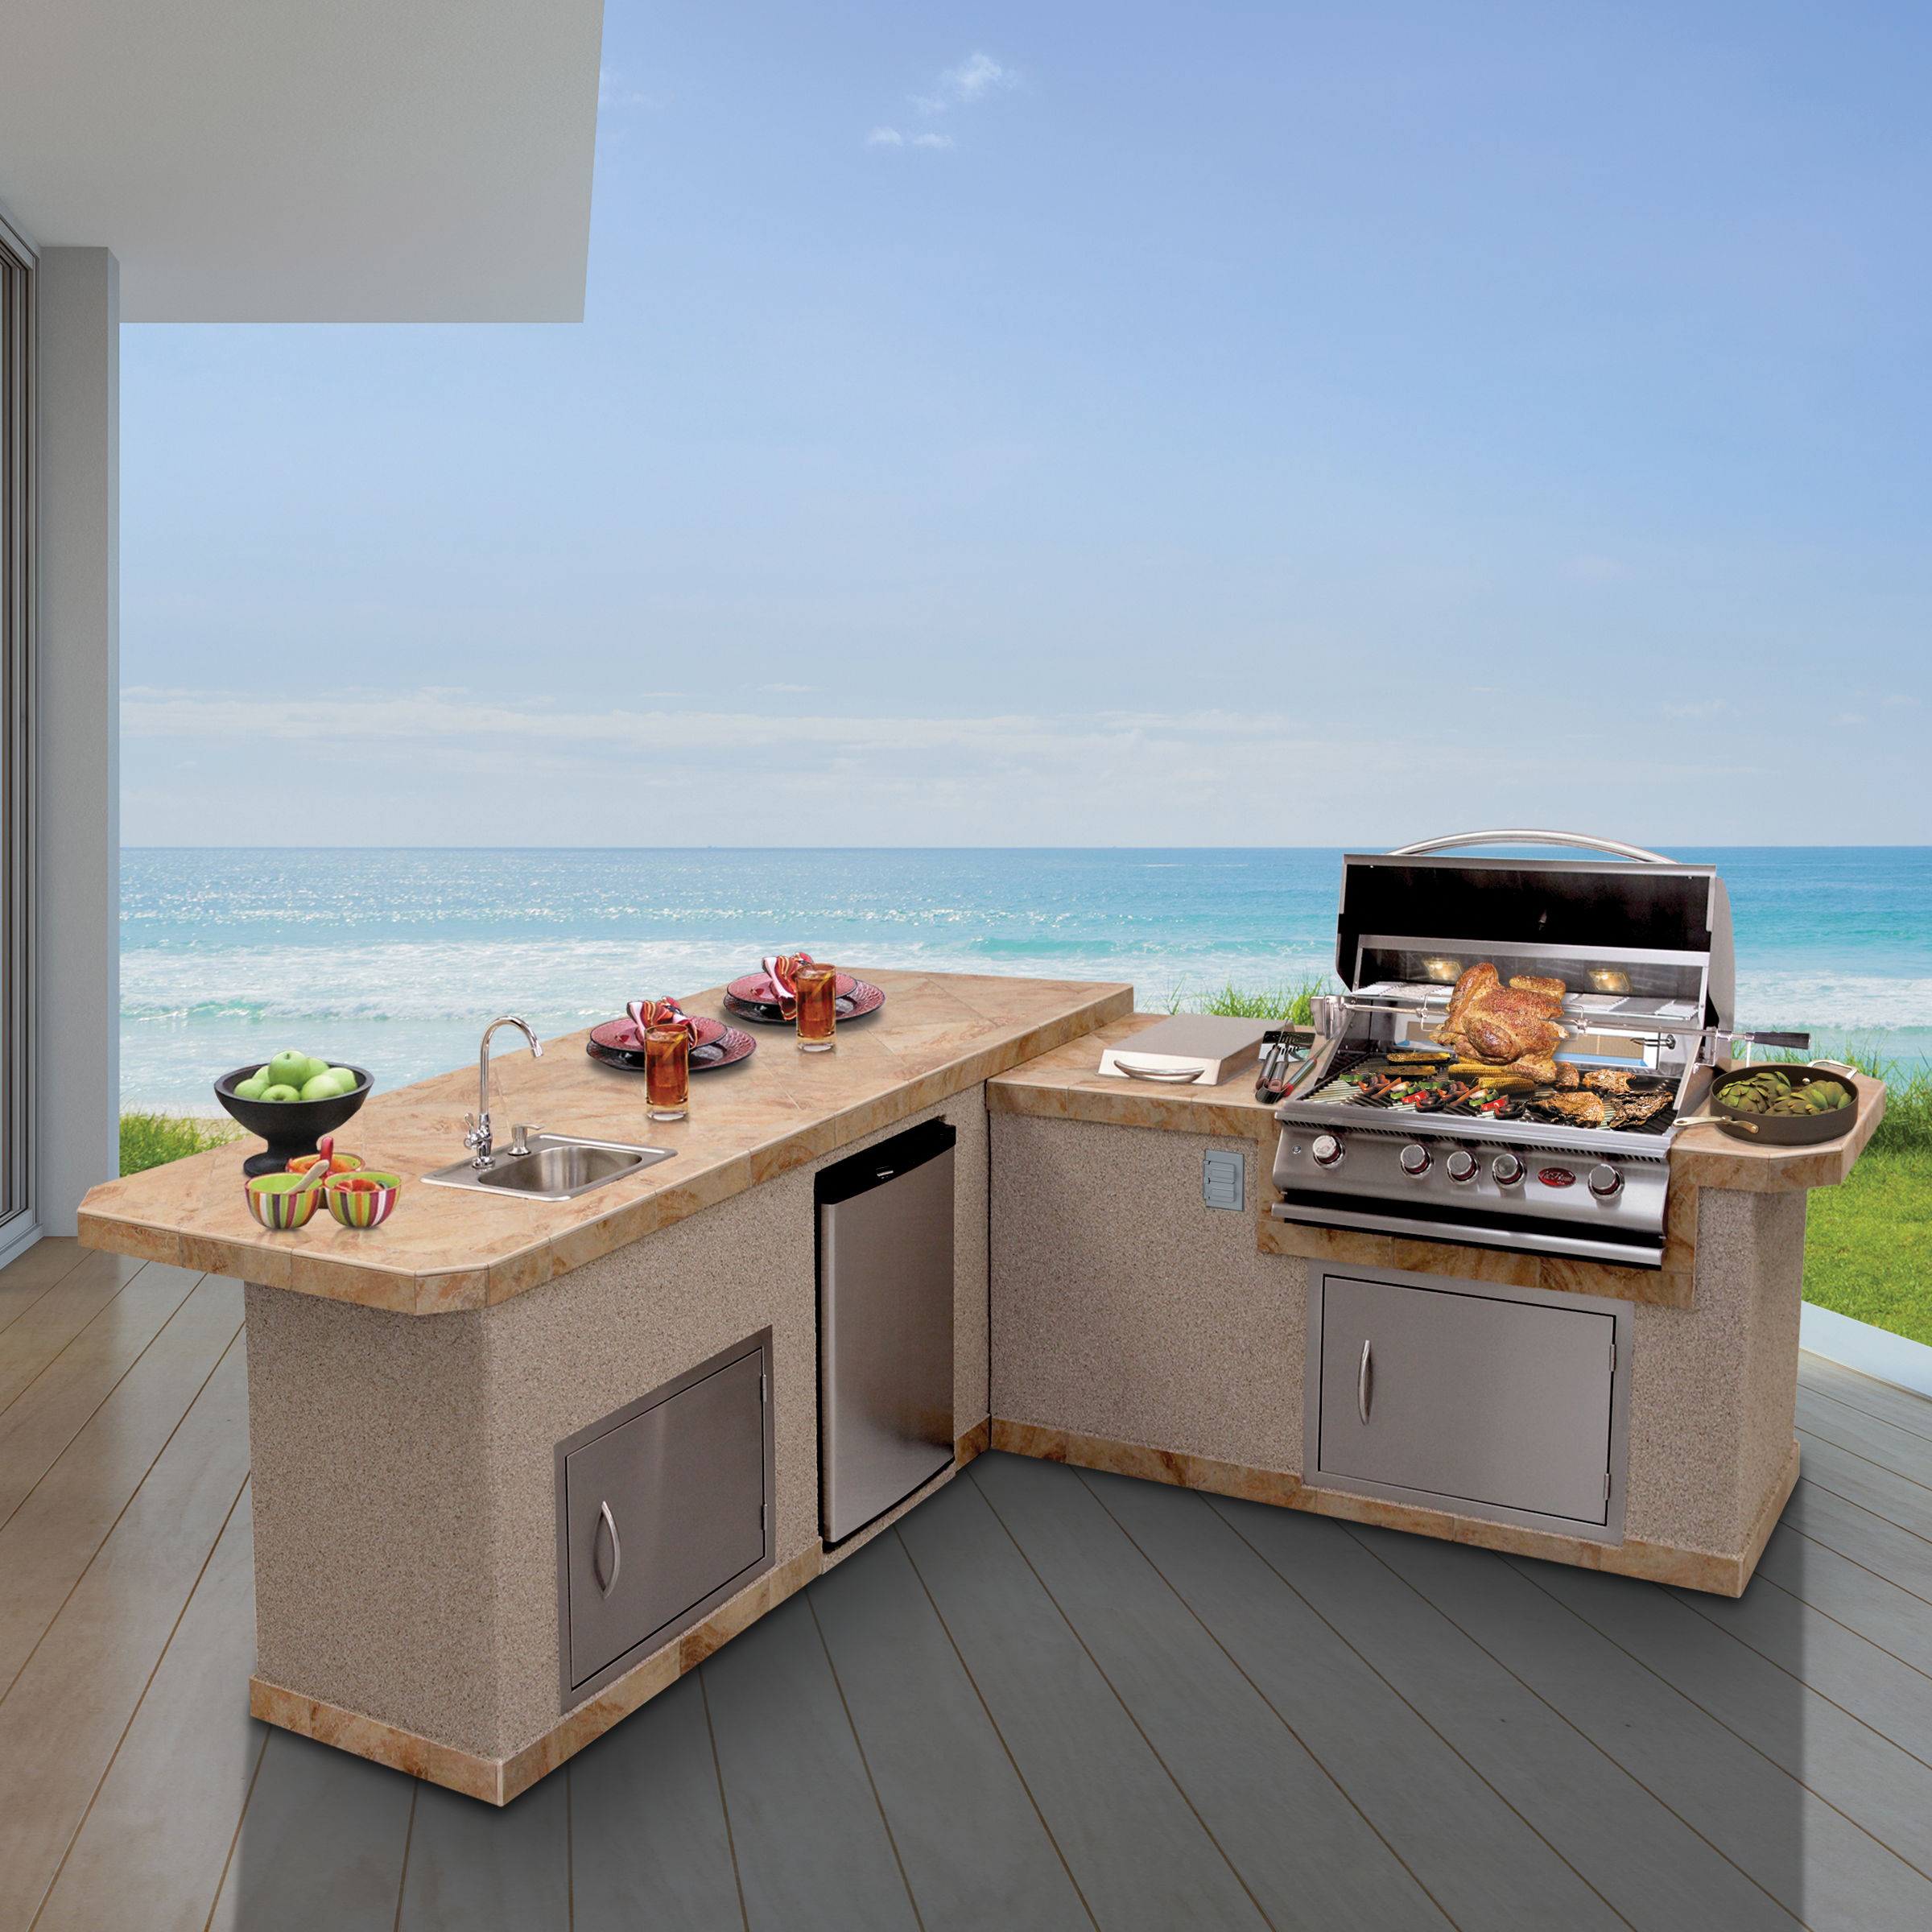 | Luxury BBQ Kitchens are a Dream with the LBK-870  Pomona, CA — (June 27, 2018) The LBK-870 is a two-piece island that comes standard with Porcelain Tile and Ameristone Stucco. You will find the 3” bottom trim a gorgeous feature that adds more style to grill on.  The LBK-870 comes standard with the P4 Grill that is a 4-burner grill with a total of 72,000 BTU. The P4 comes with a P-Grill Cover, Rotisserie, P-Griddle Tray and a P-Smoke Tray. Taking up 800 sq. in. on the island itself. Next to the grill you will find a Side Burner that comes standard. This option is wonderful for additional side dishes.  The standard features to the LBK-870 will allow you to keep everything in one place and prevent you from constantly going in and out of the house. Coming standard with the LBK-870 is a 30” door for easy access to storage. Stainless steel sink with Faucet and Soap dispenser is great for keeping your grilling area clean. Furthermore, the stainless steel refrigerator is large enough to store beverages for the whole family.  You can always add optional features that include different styles of lighting, a sound system, umbrella hole, and other stone options. The LBK-870 is highly functional and a true luxury in any backyard oasis.  About Cal FlameTM  Customers are encouraged to visit their local certified Cal Flame BBQ dealer to find more information about the Premium 6 including pricing, availability and customization.  Founded in 2000, Cal Flame is an award-winning hearth and barbecue manufacturer that offers innovative backyard solutions for every home and budget. Cal Flame lineup includes grills, drop-in accessories, customized outdoor kitchens, barbecue islands, custom barbecue carts, fireplaces and fire pits. For more information about Cal Flame, visit www.calflamebbq.com.  To schedule an interview with one of Cal Spas industry professionals contact Public Relations Specialist, Denai Rosen, at 909-620-0586 or email drosen@calspas.com

