NEWS RELEASE
FOR IMMEDIATE RELEASE

MEDIA CONTACT:
Denai Rosen, Public Relations
press@calspas.com or 1-909-620-0586

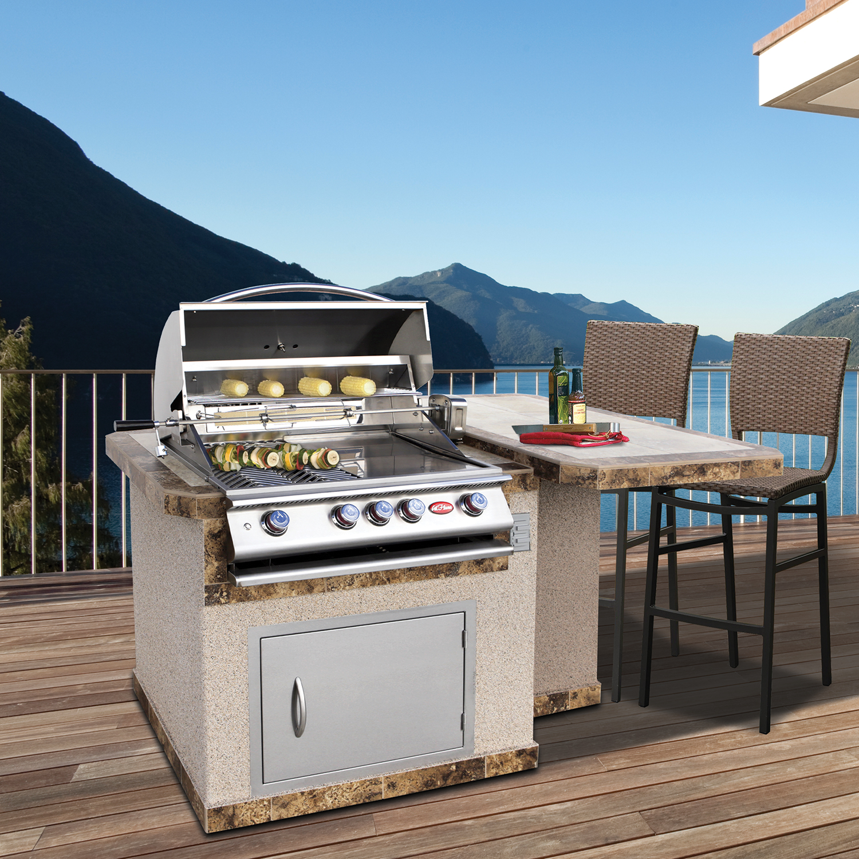  Related Links  Cal Spas Website  Cal Flame Website | Small Island for Friends and Family - LBK402  Pomona, CA — (August 28, 2018) The grilling experience has become a social event with the LBK402. This BBQ Island has a unique side table that can comfortably seat up to 3 people. The footprint for the LBK402 is 83¾” x 27”.  Built to last, the BBQ island frame is manufactured with 16-gauge galvanized steel. The LBK402 is finished with porcelain tile 12”x12”. Tile countertops can be further customized with single or two-tone styles. Durable Ameristone Stucco and elegant natural rock or stone are available in assorted colors and textures to match your Home Resort design.  The LBK402 comes standard with a P4, which is a heavy-duty 4-burner Cal Flame grill. The access door is 27” and is ideal to store a propane tank. Conveniently hook up your accessories or other items to the LBK402 using the standard outlet.  Add optional features such as LED lighting, under counter lights, FreedomTM Sound System, and umbrella hole. The LBK402 is ideal for minimal spaces such as apartments, rooftops, or patios.  ABOUT CAL FLAME ® Founded in 2000, Cal Flame is an  award-winning hearth and barbecue manufacturer that offers innovative backyard solutions for every home and budget.  Cal Flame lineup includes grills, drop-in accessories, customized outdoor kitchens, barbecue islands, custom barbecue carts,  fireplaces and fire pits. For more information about Cal Flame,  visit www.calflamebbq.com.

