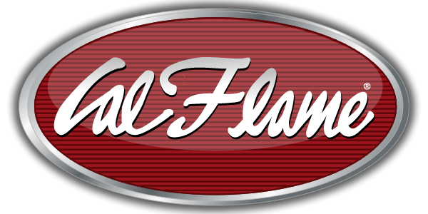
NEWS RELEASE
FOR IMMEDIATE RELEASE

MEDIA CONTACT:
Denai Rosen, Public Relations
press@calspas.com or 1-909-620-0586

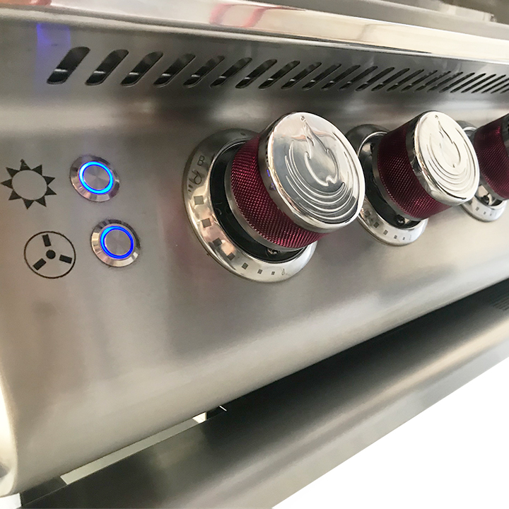  Related Links  Cal Spas Website  Cal Flame Website | Cal Flame Independent Igniting Cast Stainless Steel Knobs  Pomona, CA — (July 31, 2018) What makes a Cal Flame Grill very special is how you light up the grill. Not only is Cal Flame the very first in the industry to add a leading edge feature such as cast stainless steel knobs, but also having independent igniters for each knob.  With Cast Stainless Steel, the knobs will stay cool, and the splashguard will prevent the heat from getting to you as well. Push the knob, and the gas will be injected into a 15,000 BTU Stainless Steel Burner. Let the gas fill the valve, turn it, and it will ignite the torch sending flames into the orifice.  Our Piezo and Blowtorch system allows the grill to be more forgiving. You will never have to look for a lighter since each knob will always light. Additionally, when you start the grill there will be no flare up that is caused by spiders making webs and gas deflecting.  Cal Flame technology will allow consistent heating therefore your burners will never warp! The firebox of the grill is double welded construction; say goodbye to grease or rainwater in your grill.  Let’s put it this way, this is the best grill you can find on the market today. Using the best material on the market, with leading edge technology, and functions that you cannot find anywhere else. We have patented exclusive features that make Cal Flame grills the best grill you can get.  ABOUT CAL FLAME ® Founded in 2000, Cal Flame is an  award-winning hearth and barbecue manufacturer that offers innovative backyard solutions for every home and budget. Cal Flame lineup includes grills, drop-in accessories, customized outdoor kitchens, barbecue islands, custom barbecue carts, fireplaces and fire pits. For more information about Cal Flame, visit www.calflamebbq.com.

