NEWS RELEASE
FOR IMMEDIATE RELEASE

MEDIA CONTACT:
Denai Rosen, Public Relations
press@calspas.com or 1-800-CAL-SPAS

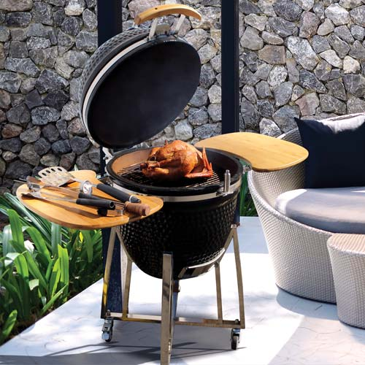  Related Links  Cal Spas Website  Cal Flame Website | The perfect Smoker for Small Spaces  Pomona, CA — (August 7, 2018) The Kamado Smoker Grill is made for small spaces including apartments and small patios. How is works is the Kamado is made from heavy ceramic. The inside retains heat, then the heat is absorbed and refracted within the firebox, a fireproof fabric seal maintains heat within the vessel.  Made to grill and smoke your meat to the best flavor possible! Desired temperature can be achieved and maintained by precise control of airflow via the top and bottom vents.  Great features to highlight are the slide-out ash drawer for easy cleaning. Stainless steel stands to easily move around, folding side shelves to put utensils; cast iron top vent with temp gauge for accuracy. With the Kamado you will always grill with the right heat.  Additional accessories are available for purchase. By using the Kamado Grill you are getting a smoker that is high quality, easy to use, easy to clean and will leave your food tasting better than ever.  ABOUT CAL FLAME ® Founded in 2000, Cal Flame is an  award-winning hearth and barbecue manufacturer that offers innovative backyard solutions for every home and budget. Cal Flame lineup includes grills, drop-in accessories, customized outdoor kitchens, barbecue islands, custom barbecue carts, fireplaces and fire pits. For more information about Cal Flame, visit www.calflamebbq.com.

