NEWS RELEASE
FOR IMMEDIATE RELEASE

MEDIA CONTACT:
Denai Rosen, Public Relations
press@calspas.com or 1-800-CAL-SPAS

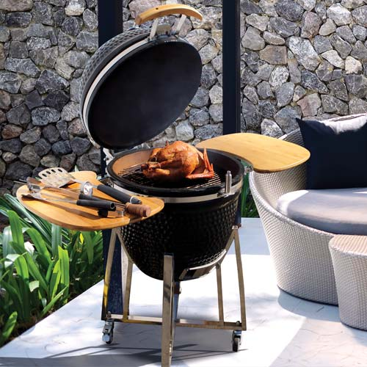  Related Links  Cal Spas Website  Cal Flame Website | Kamado Smoker Grill Cart  Pomona, CA — (May 23, 2018) If you are looking for a grill that has a small footprint and easily moves then the Kamado Smoker Grill is ideal for you. Made from heavy ceramic, the interior retains the heat, heat is absorbed and refracted within the firebox located on the bottom of the smoker. This grill features a fireproof fabric seal to maintain heat within the vessel.  The Kamado grill is made to grill slow and cool smoking. It does not require constant fire tending, unlike traditional smokers. Desired temperature can be achieved and maintained by precise control of airflow via the top and bottom vents.  Cal Flame Kamado Grill has many great features. Including the slide-out ash drawer to easily clean. Stainless steel stands with locking wheels to easily move around and lock to stay in place. Folding side shelves to keep food or utensils in addition to adding elegance in style. Additionally, the cast iron top vent with temp gauge and Cal Flame logo is critical for grill success. Always grill with the right heat using the standard built-in Cal Flame Temperature Gauge.  If you are looking for something that works really well, that taste really good, and is super convenient then this grill is made for you. Additional accessories are separately available for purchase. Perfect for cooking thoroughly with out drying out, leaving it moist with full, smoky flavor.  ABOUT CAL FLAME ®  __________________________________________________________  Founded in 2000, Cal Flame is an  award-winning hearth and barbecue manufacturer that offers innovative backyard solutions for every home and budget. Cal Flame lineup includes grills, drop-in accessories, customized outdoor kitchens, barbecue islands, custom barbecue carts, fireplaces and fire pits. For more information about Cal Flame, visit www.calflamebbq.com.

