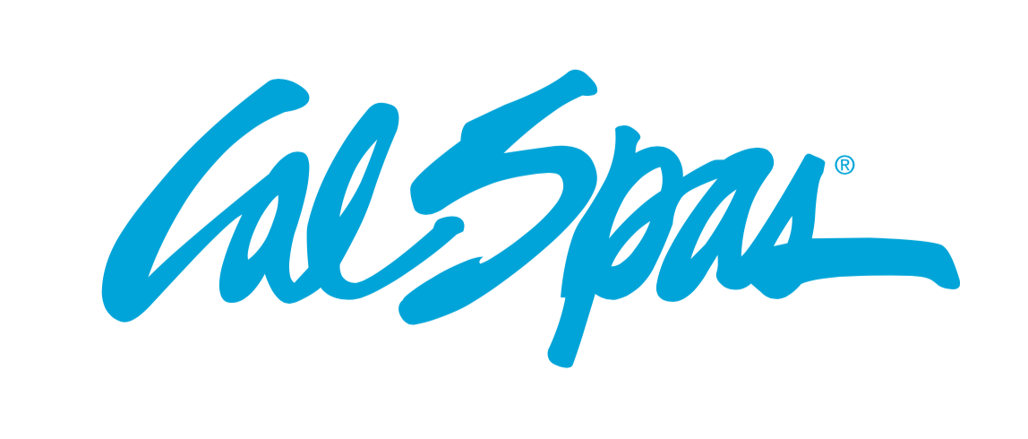
NEWS RELEASE
FOR IMMEDIATE RELEASE

MEDIA CONTACT:
Denai Rosen, Public Relations
press@calspas.com or 1-800-CAL-SPAS
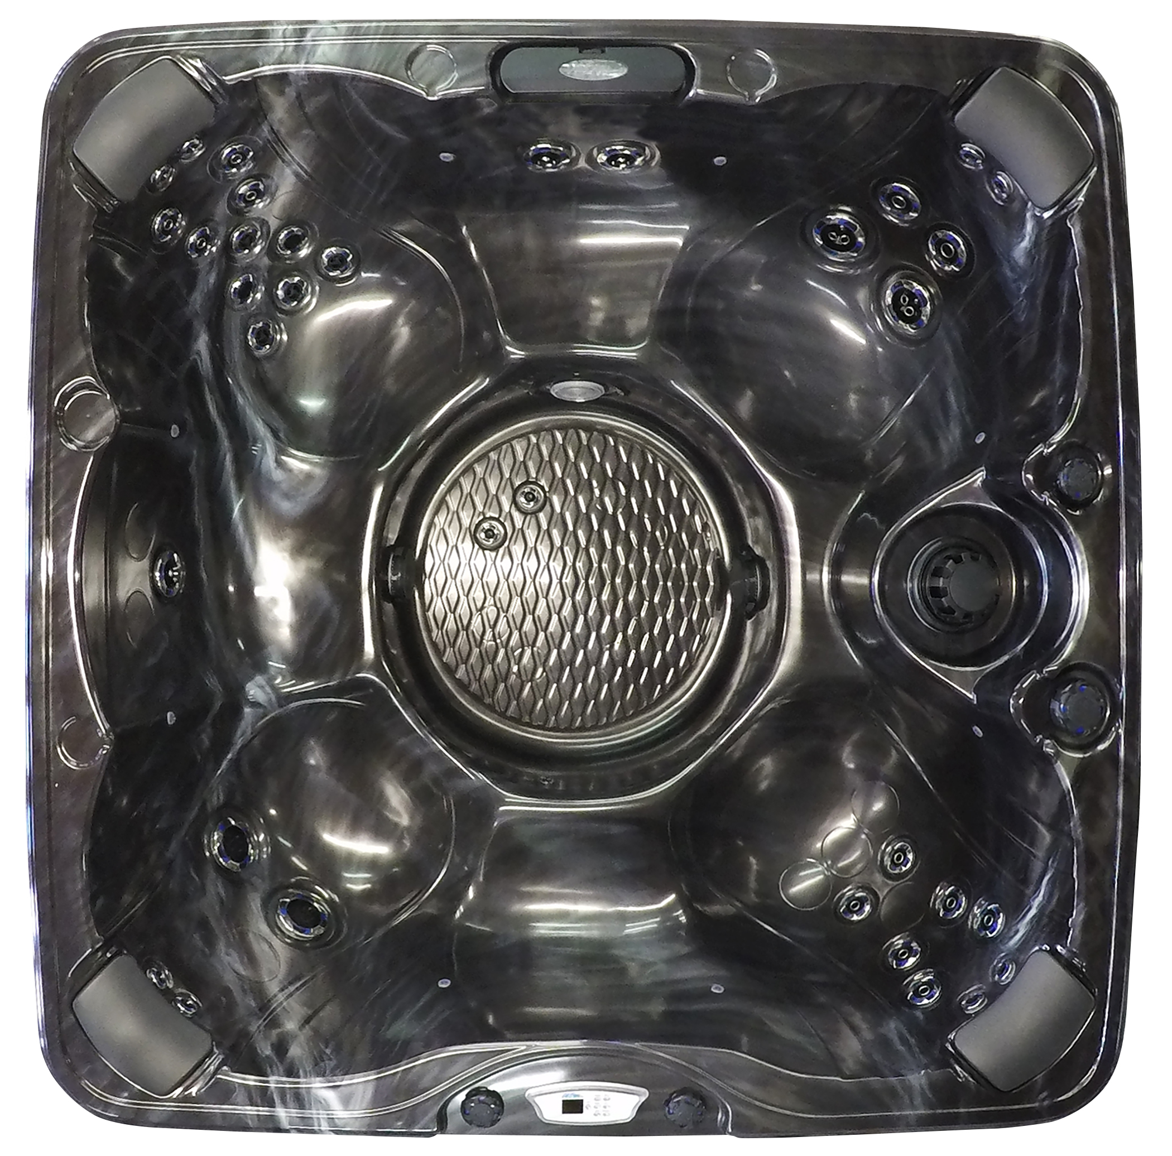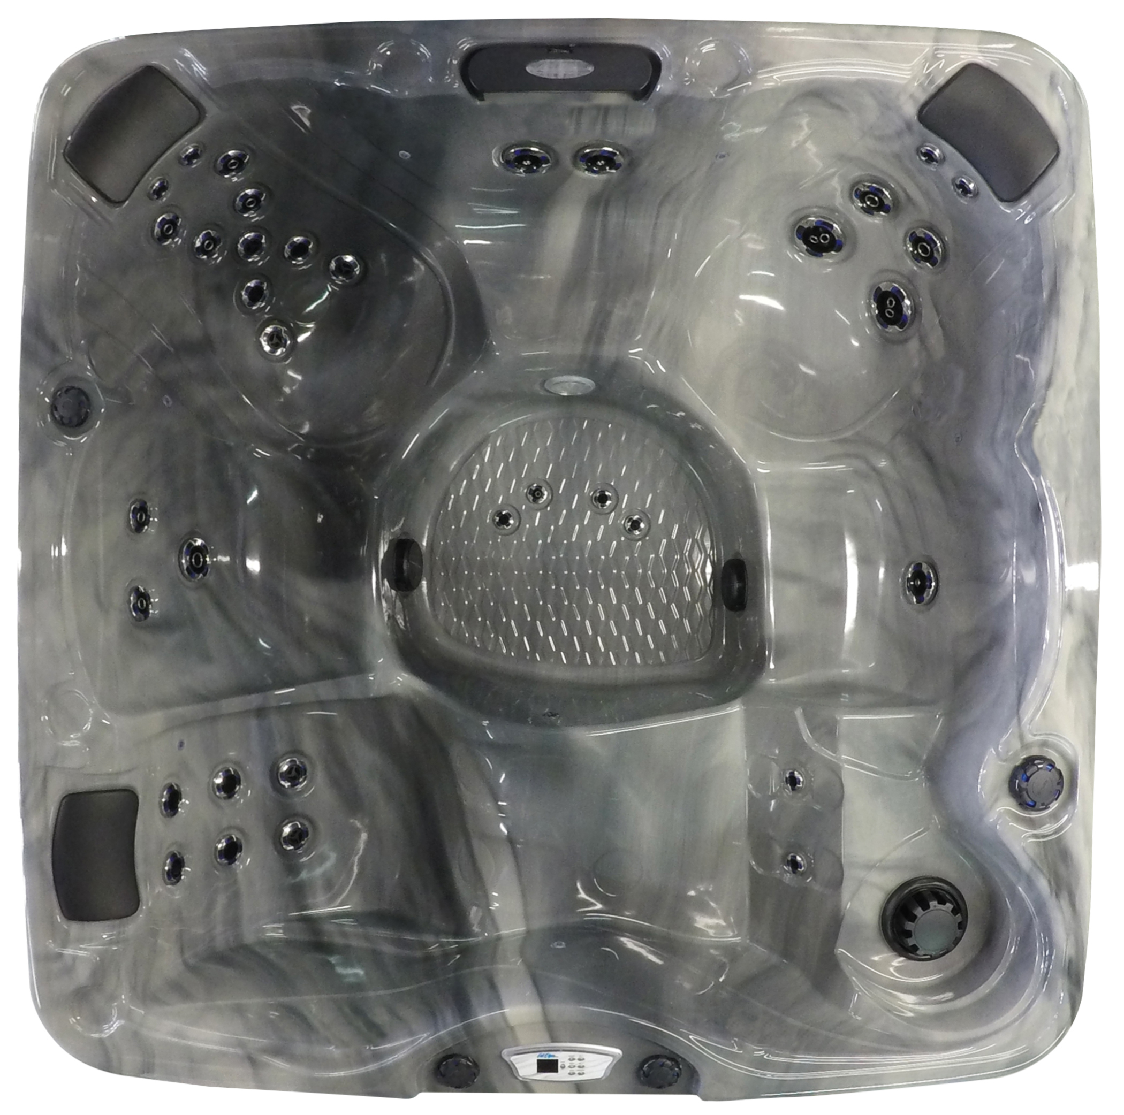  Related Links  Cal Spas Website | Escape-735 For The Win!  Pomona, CA — (May 24, 2018) The newest Cal Spa Pacifica EC-735 Lounge and Bench molds can fit up to six people. Deluxe colors are of your choice for the strong Cal Spas Acrylic Shell. This spa dimensions are 84”x84”x40¹/₂, weighing 800 lbs, and filling up to 425 lbs water capacity.  Eliminator High PerformanceTM Pump with 2x6.0 BHP will seamlessly operate all 35 Jets at an Operating Voltage of 240V. The Escape Pacifica-735 comes with exclusive VelocityTM Jets with SQR technology and a Curved Cascade LED Waterfall. For extra comfort (3) Cal Spas Y-Pillows come standard. Additionally, the Premium Underwater LED Lighting Package can light up from the bottom up to give you the best overall lighting.  Cal Spas WhisperHotTM 5.5kW Titanium Heater is one-of-a-kind and long lasting. Keep your spa at the right temperature with the highest amount of power in the industry. The controller that comes with the EC-735 is the Cal Spas Wave, which is very user friendly; by the touch of the finger you can easily adjust the jets, temperature, and LED lights.  To keep heat in, our Thermo-ShieldTM technology starts by installing a unique material primarily comprised of post-consumer recycled denim. In result, we find that this method directs motor and equipment heat back into the spa retaining residual heat and increasing energy efficiency.  Using pressure treated wood cabinet frame for the spa is the best way to go. Cal Spas cabinet frames have a new treatment to resist rot, corrosion and insects. Additionally, the Cal PreferredTM Cabinet Panels on the Escape-725 are ideal and low maintenance due to highly durable panels that mimic the look of natural wood.  Optional items are always nice, but with this luxury item, everything you need comes standard. If you are looking to add a feature, we have many items that may interest you including ATS Plus, AAT seat, Pure SilkTM, C-Light^{TM,} Hybrid Sanitizing System, 24/7 Filtration System, Cal Spas Wi-Fi and last but not least the FreedomTM Sound System.  For further inquiries about becoming a Cal Spas Dealer please contact email dealerrelations2@calspas.com  ABOUT CAL SPAS ®  Cal Spas was founded in 1978 as a provider of luxury hot tubs. Today, the celebrated hot tub giant is world renowned as the #1 Global Manufacturer of Home Resort Products™. The company produces premium collections of lifestyle products from its headquarters in Pomona, California and distributes worldwide through a network of specialty dealers. The Cal Spas brand family of products includes Cal Spas hot tubs and swim spas, Cal Designs gazebos, Cal Heat indoor and outdoor saunas, and Cal Flame high-end barbecue grills, outdoor barbecue islands, outdoor fireplaces and fire pits. Learn about Home Resort Living and find a local authorized dealer at www.calspas.com.

