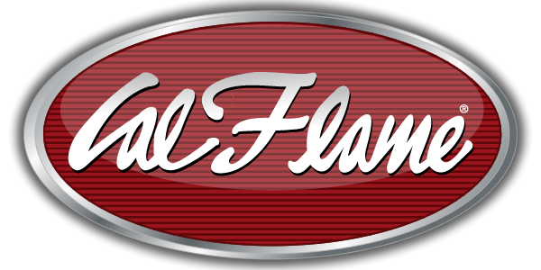
NEWS RELEASE
FOR IMMEDIATE RELEASE

MEDIA CONTACT:
Denai Rosen, Public Relations
press@calspas.com or 1-800-CAL-SPAS

Related Links  Cal Spas Website  Cal Flame Website  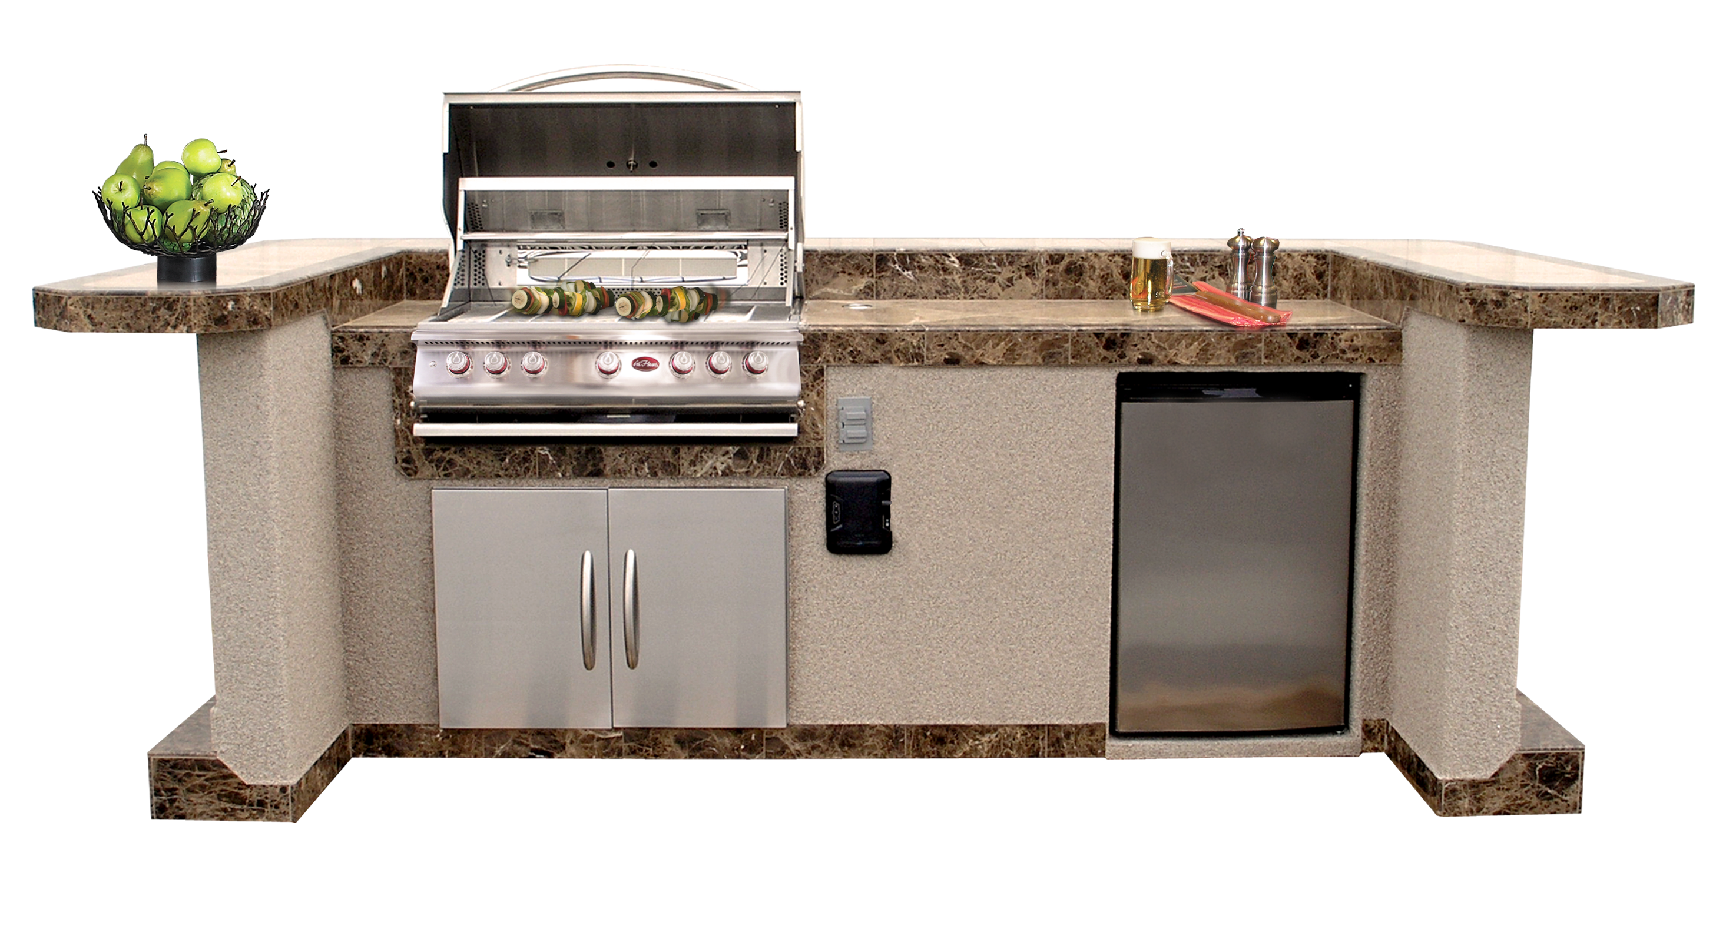 | What you need to know about our Custom Pavilion BBQ Islands  Pomona, CA — (April 3, 2018) The time is finally here; you get to design your dream backyard. A backyard that is full of luxury and convenience for the whole family. Imagine each holiday spent in your private home with a marvelous grill that you get to call your own. Now it is time to make that dream happen. Cal Flame builds Pavilion BBQ Kitchens that are custom to your likings. We have five models you can choose to customize.  When it comes to customizing your BBQ Island, there are a few factors to think about. First, what are your color choices? We have a color chart to show you what materials are offered so you can make the best choice for your home. Next, it is time to choose your base accessories. Options are a 3” bottom trim, solid footrest w/ bottom, or a 2’ extension to make the island a total of 8’.  Now, it is time to think about which grill to implement. You can  choose to go with any grill that best suits your lifestyle, they all have their perks, but the most common standard grills are the Premium Grills.  When it comes to choosing how much storage you need we offer many options to avoid multiple trips to and from the house. To name a few, you can choose from single or double access doors, door and drawer combos, complete utility storage set, paper towel storage, and a propane tank drawer.  In your custom Pavilion you can also choose accessory drop-ins.  Drop in accessories are: food warmer, cocktail center, bar, ice bucket, hibachi grill, and steel faucet & soap dispenser. Additionally, you can add a refrigerator to get your beer on tap! Or just add a regular refrigerator for your cool beverages.  All your entertainment in one location! When the sun goes down, the lights come on. Add LED lighting, under counter lights, and a FreedomTM Sound System to make your pavilion come to life at night.  [more]  Customers are encouraged to visit their local certified  Cal Flame BBQ dealer to find more information about the  Premium 6 including pricing, availability and customization.  ABOUT CAL FLAME ® Founded in 2000, Cal Flame is an  award-winning hearth and barbecue manufacturer that offers innovative backyard solutions for every home and budget. Cal Flame lineup includes grills, drop-in accessories, customized outdoor kitchens, barbecue islands, custom barbecue carts, fireplaces and fire pits. For more information about Cal Flame, visit www.calflamebbq.com.

