NEWS RELEASE
FOR IMMEDIATE RELEASE

MEDIA CONTACT:
Denai Rosen, Public Relations

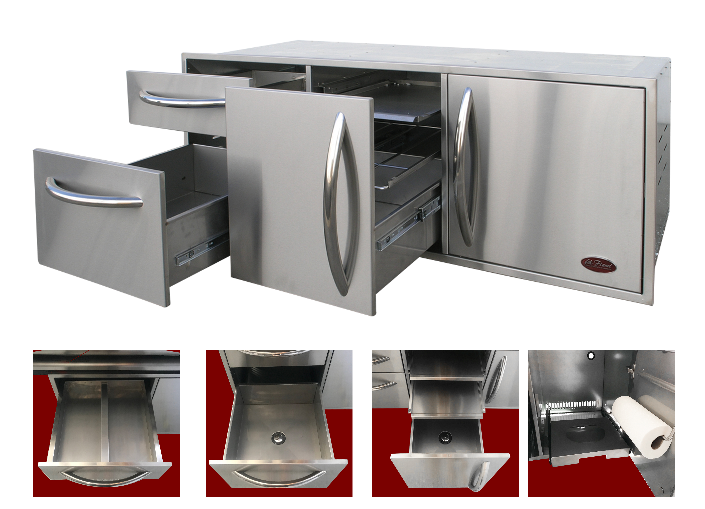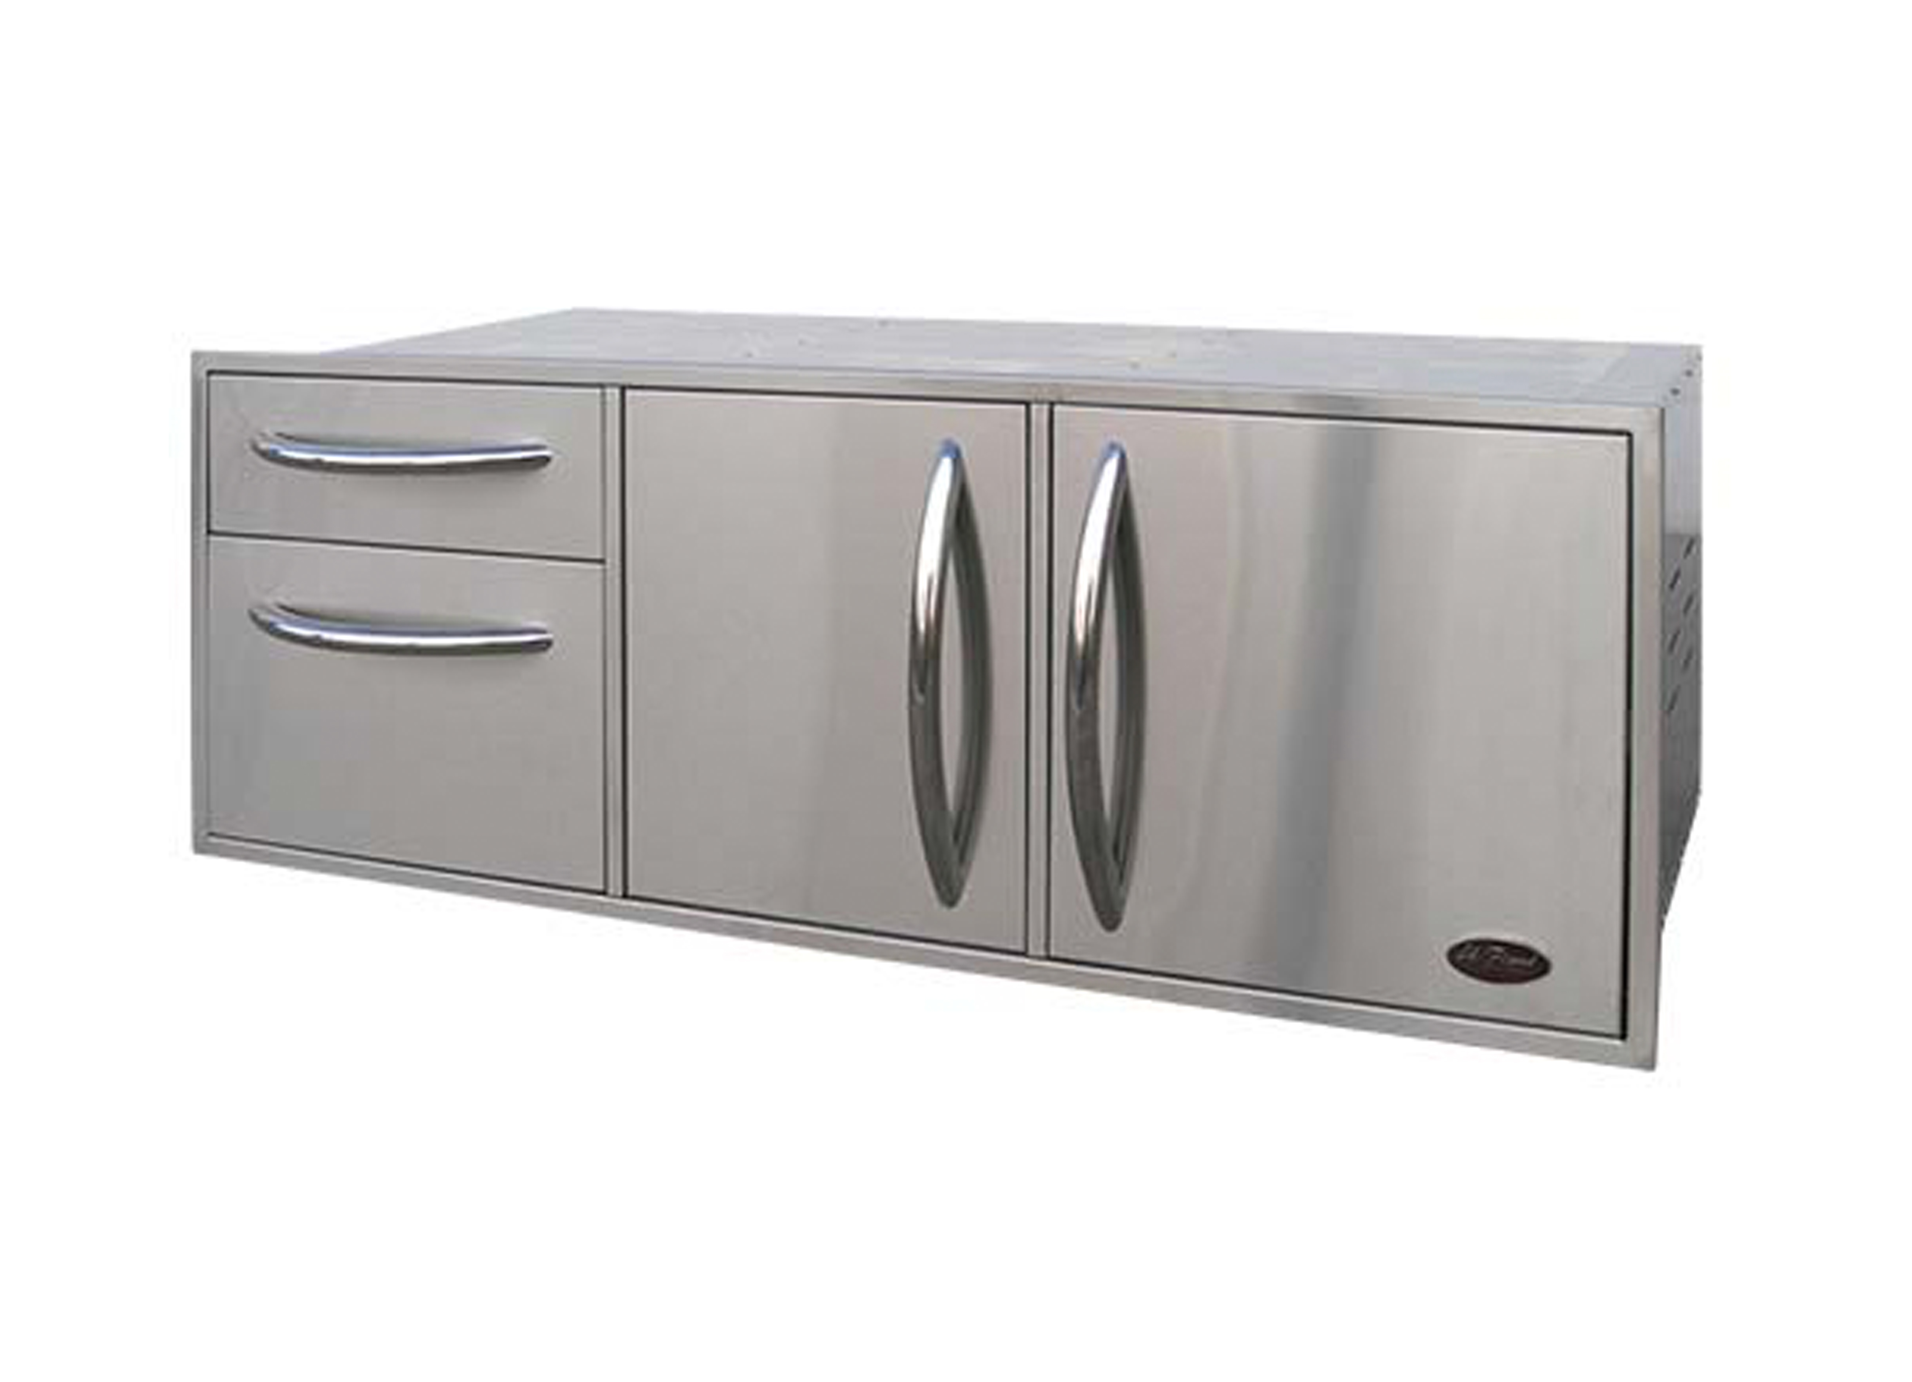  Related Links  Cal Spas Website  Cal Flame Website | The Only Utility Set You Will Ever Need  Pomona, CA — (October 25, 2018) The Cal Flame Complete Utility set is the ultimate storage for a backyard kitchen. This specific Utility set is convenient to store food, ice, cooking utensils and any other items you wish to keep tucked away in your outdoor kitchen. Here are the details:  - 52½" x 20¾" x 20¾"  - 430 Stainless Steel Construction  - (4) Drawer Storage Unit  - (2) Ice Bucket with Drain  - Propane Storage or Waste Basket  - Insulated to Keep Ice From Melting  - Industrial Strength Hidden Hinge  - Optional Paper Towel Holder  - Optional Spice Rack  - Extra Large Handles  The Cal Flame Utility Storage includes a drawer with a removable divider to store one or two different types of meat. Underneath is a drawer ideal for storing ice with a drain feature. In the middle drawers, two gliding stainless steel trays are perfect for storing pre-made food or utensils. Under the two trays is another drawer that is ideal for storing ice because of the drain that is found on the bottom. The drawer on the right is a sliding placeholder for the propane tank or a wastebasket. Additionally, you can add a paper towel rack or spice rack to the utility storage for more convenience.  ABOUT CAL FLAME ®  Founded in 2000, Cal Flame is an award-winning hearth and barbecue manufacturer that offers innovative backyard solutions for every home and budget. Cal Flame lineup includes grills, drop-in accessories, customized outdoor kitchens, barbecue islands, custom barbecue carts, fireplaces and fire pits. For more information about Cal Flame, visit www.calflamebbq.com.

