NEWS RELEASE
FOR IMMEDIATE RELEASE

MEDIA CONTACT:
Denai Rosen, Public Relations

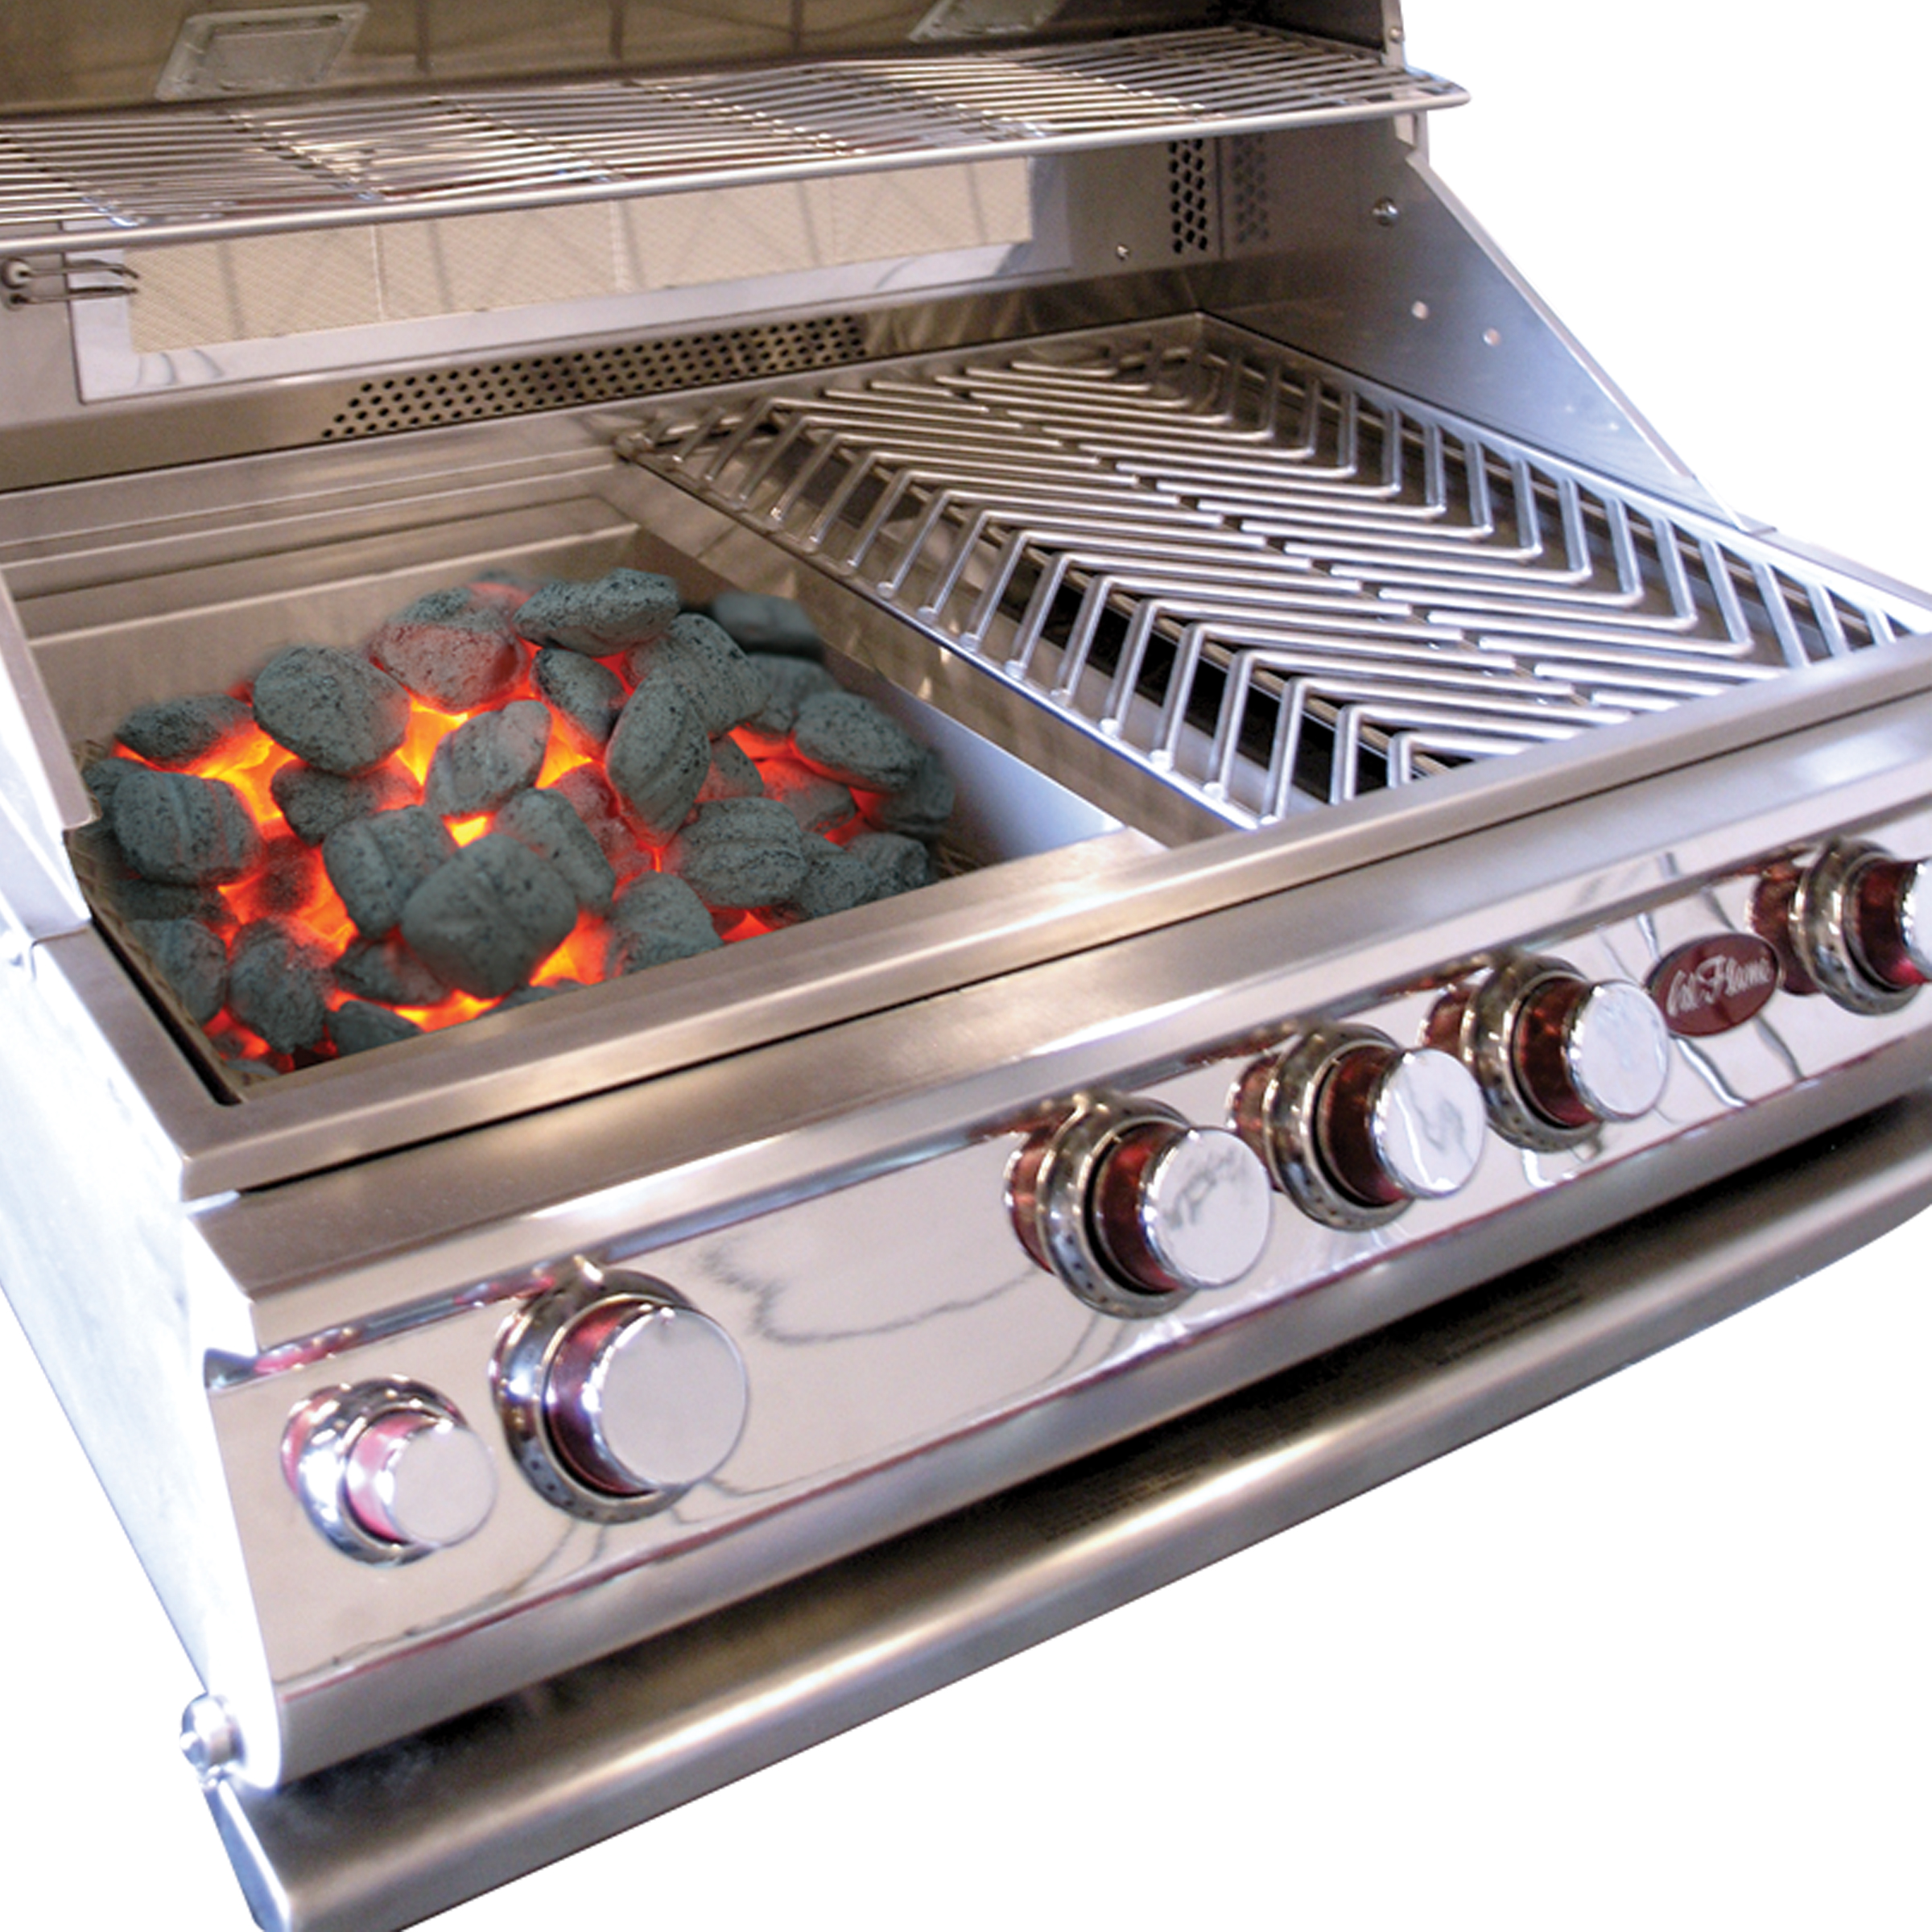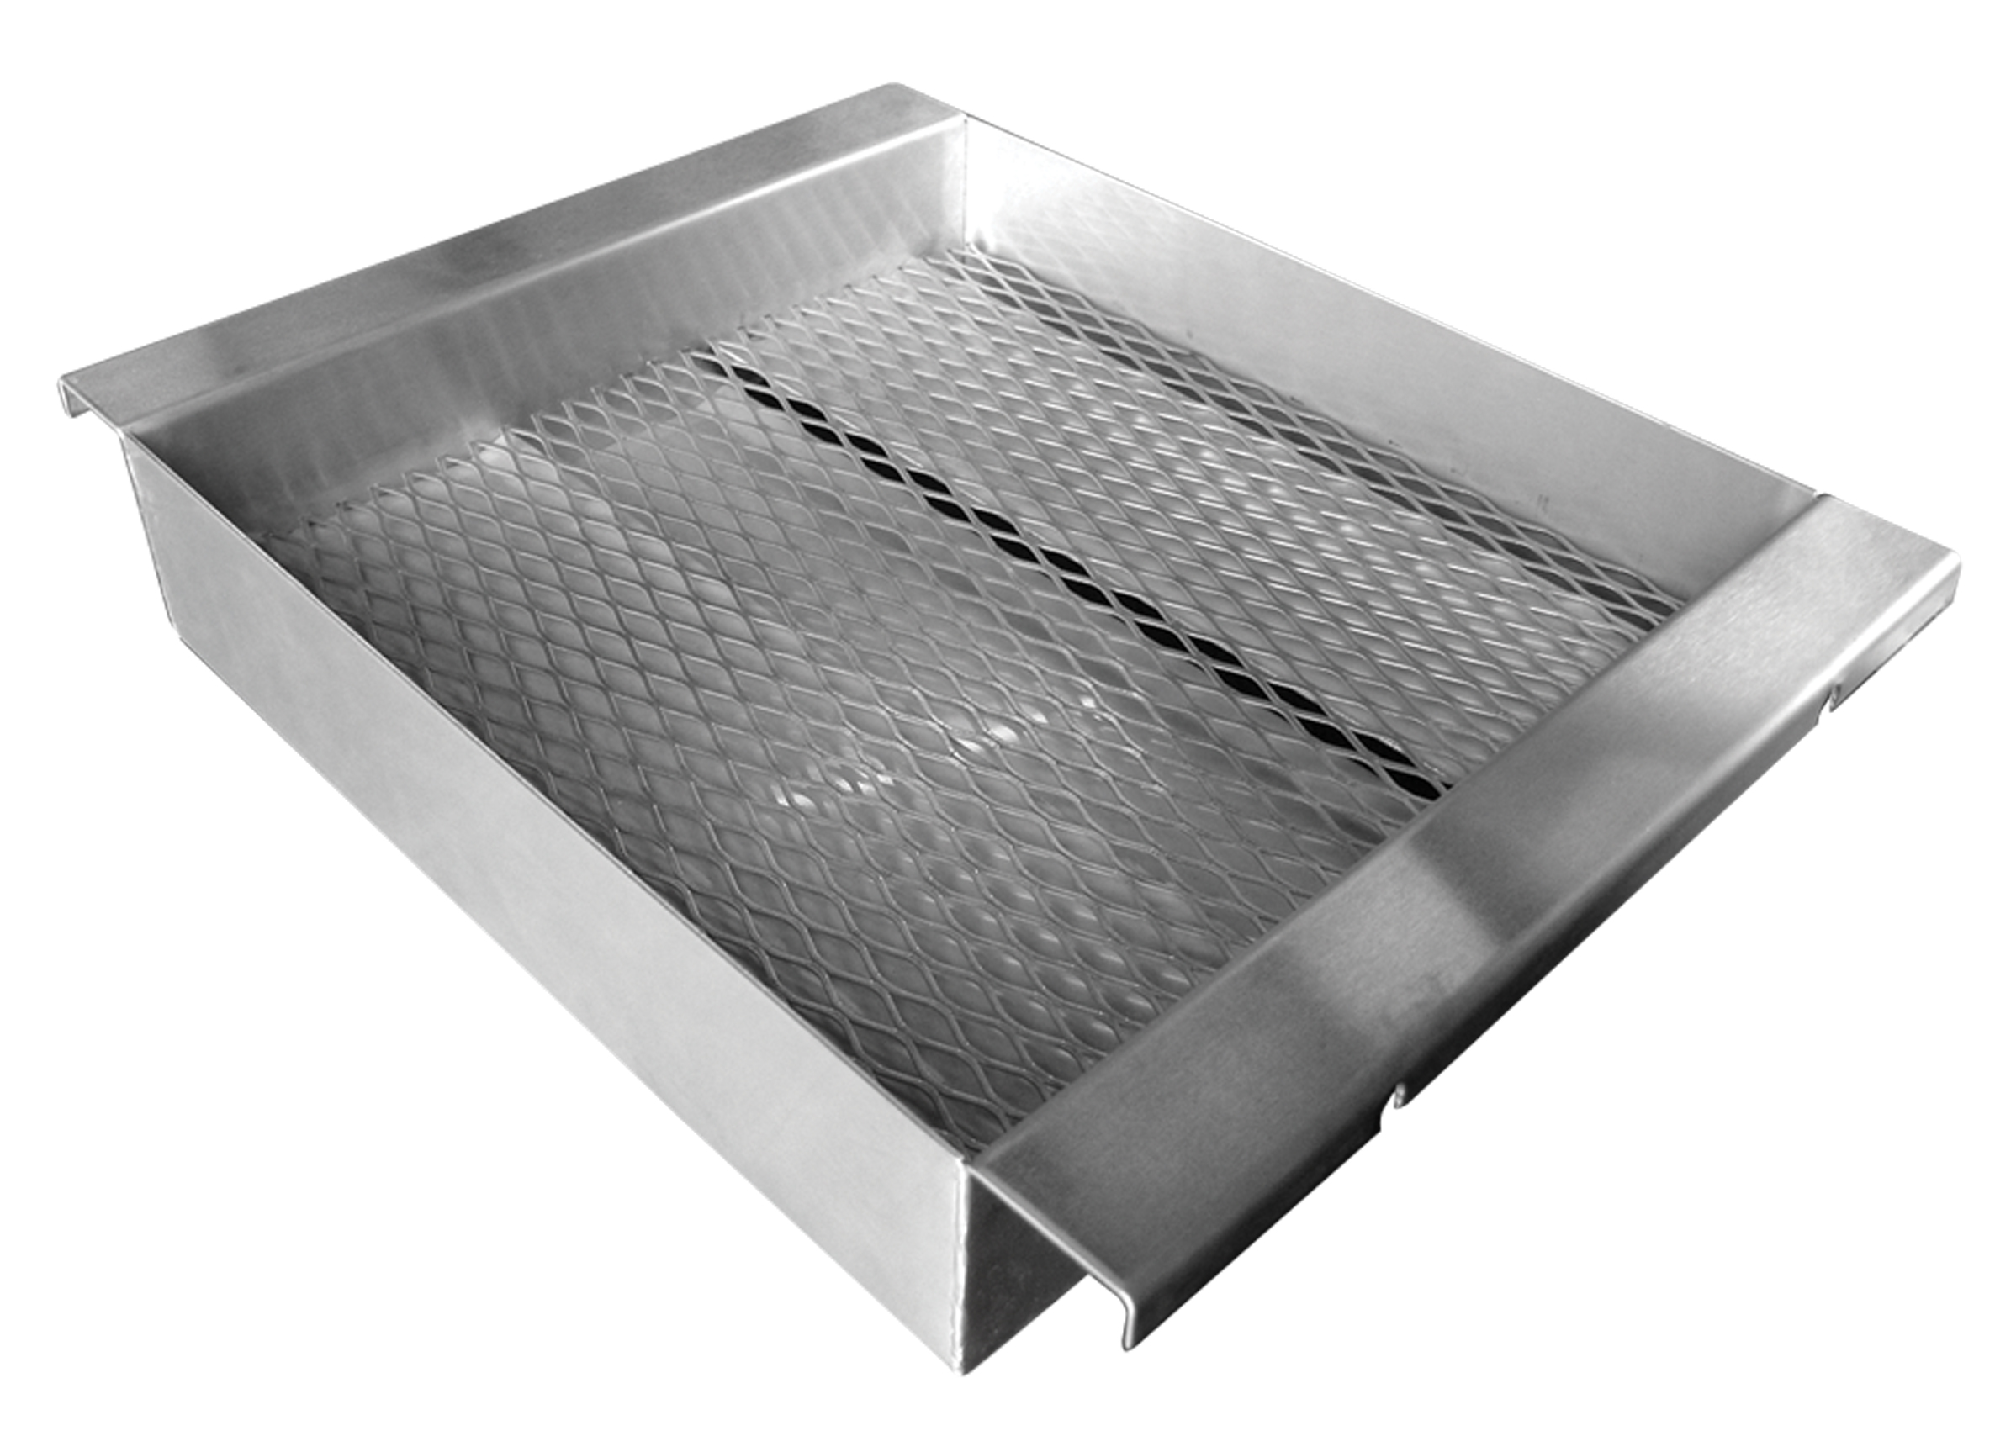  Related Links  Cal Spas Website  Cal Flame Website | Transform any Cal Flame Gas Grill into a Charcoal Grill  Pomona, CA — (November 19, 2018) The Charcoal Tray is a versatile accessory for Cal Flame grills that can turn your propane or natural gas Cal Flame grill into a charcoal grill or smoker by simply removing a section of the V-Grates on your grill and replacing them with the Charcoal tray, then adding the exclusive Cal Flame V-Grates back on to grill your favorite food.  Enjoy the flavor of charcoal as often as you want on your gas grills. Simply load the removable tray with the charcoal of your choice and allow the gas burners to light the charcoal. Once the coals become hot, turn the burners off, and grill as if you were using a non-gas grill. The benefits of using a charcoal tray will be creating a wholesome smoke like flavor to grilled food.  Here are some key features to remember:  - Width: 13.63” Depth: 17.63” Height: 3”  - Made with Stainless Steel Construction  - Designed to fit flawlessly on any Cal Flame Gas Grills  - Easy to add and remove from Cal Flame Gas Grills  - Turn on with out lighter fluid using the burners  - Ideal for indirect cooking or to add smoke flavor  - Dishwasher Safe and Non-Stick Material  The Cal Flame Charcoal Tray is a wonderful accessory to keep. Enhance the flavor of your food by switching up your gas grill for a charcoal grill. If you are interested in other great Cal Flame accessories that will enhance your grilling flavor take a look at the rotisserie basket, sear zone burner, and the deep fryer set. Take luxury to the next level with Cal Flame grilling accessories.  [more]  ABOUT CAL FLAME ®  Founded in 2000, Cal Flame is an award-winning hearth and barbecue manufacturer that offers innovative backyard solutions for every home and budget. Cal Flame lineup includes grills, drop-in accessories, customized outdoor kitchens, barbecue islands, custom barbecue carts, fireplaces and fire pits. For more information about Cal Flame, visit www.calflamebbq.com.

