NEWS RELEASE
FOR IMMEDIATE RELEASE

MEDIA CONTACT:
Denai Rosen, Public Relations

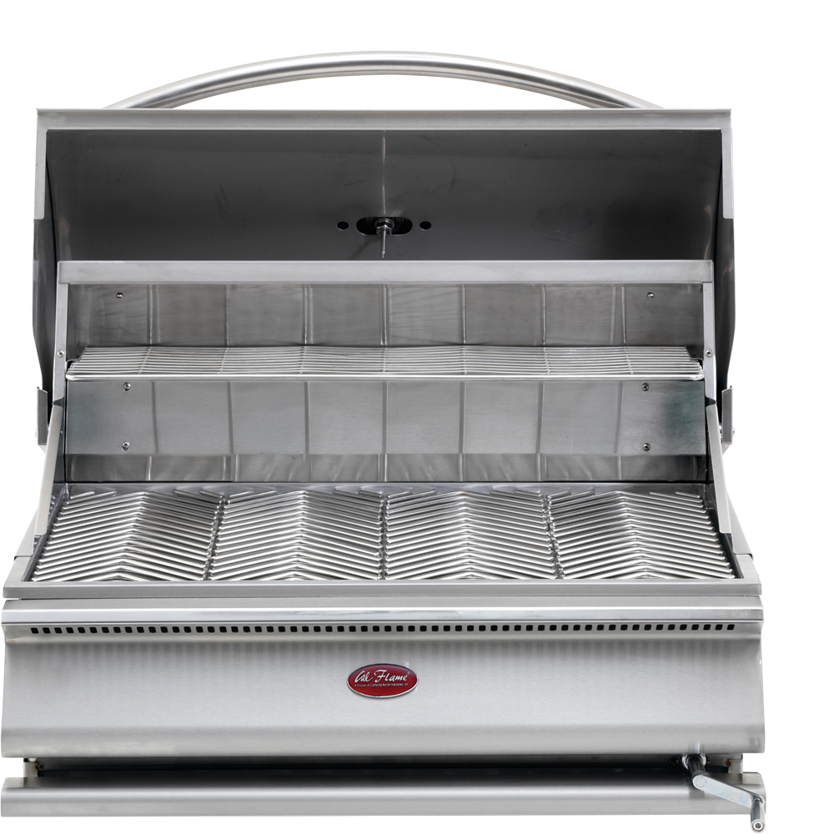  Related Links  Cal Spas Website  Cal Flame Website | The Most Luxurious Charcoal Grill from Cal Flame  Pomona, CA — (January 15, 2019) The Cal Flame Charcoal Grill is one-of-a-kind, built-in grill. You will not find another built-in stainless steel Charcoal Grill on the market.  Cal Flame is cutting edge giving you a Charcoal Grill with 800 sq. in. of cooking surface. Built with 430 Stainless Steel construction with a double layered welded hood and a one-piece heavy-duty handle.  The Cal Flame Charcoal Grill includes a built-in extra large temperature gauge, two-position full width warming rack, and an exclusive patented designed removable heavy duty V-Grate cooking grate.  Control the heat by adjusting the charcoal tray with the handle crank system. For convenience and safety, a vented splashguard and full width stainless steel drip tray on rollers comes equipped with the Cal Flame Charcoal Grill.  - 430 Stainless Steel 16-Gauge Construction  - Removable Heavy-Duty Grates with V-Grate Cooking Design  - Adjustable Charcoal Tray with Handle Crank System  - Two-Position Full-Width Warming Rack  - Built-In Temperature Gauge  The Cal Flame Grill is a pleasure to own due to the construction and the exclusive features. You can choose to add Cal Flame drop in accessories to enhance the flavor of any meal. Choose to add a smoker box, Griddle Tray, or Grill cover.  ABOUT CAL FLAME ®  Founded in 2000, Cal Flame is an award-winning hearth and barbecue manufacturer that offers innovative backyard solutions for every home and budget. Cal Flame lineup includes grills, drop-in accessories, customized outdoor kitchens, barbecue islands, custom barbecue carts, fireplaces and fire pits. For more information about Cal Flame, visit www.calflamebbq.com.

