NEWS RELEASE
FOR IMMEDIATE RELEASE

MEDIA CONTACT:
Denai Rosen, Public Relations
press@calspas.com or 1-800-CAL-SPAS
Related Links  Cal Spas Website  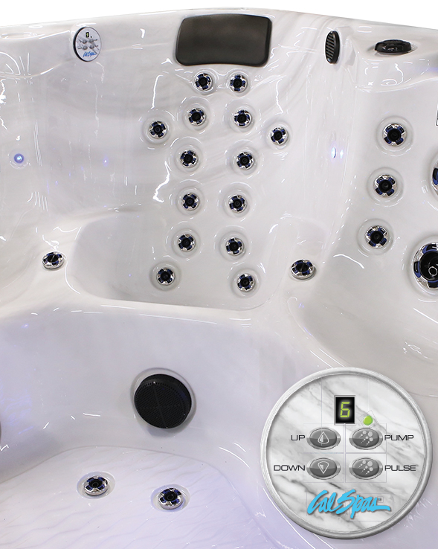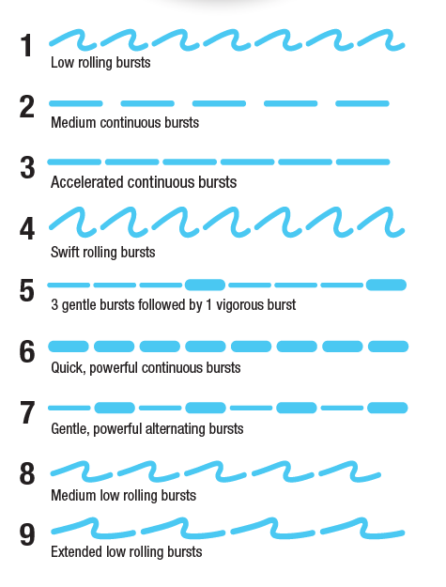 | New updates to the Aquatic Therapy System (ATS)  Pomona, CA — (July 16, 2018) The Cal Spas Exclusive ATS seat is one of a kind feature that you cannot find anywhere else in the hot tub industry. In the late 90’s, Cal Spas has patented the ATS technology to be exclusive to Cal Spas Hot Tubs only. Since then we have made improvements that stand out. We use to have 7 pressure levels, but we have now upgraded to 9. See full list below:  - Low rolling bursts,  - Medium continuous bursts  - Accelerated continuous bursts  - Swift rolling bursts  - 3 gentle bursts followed by 1 vigorous burst  - Quick powerful continuous bursts  - Gentle powerful alternating bursts  - Medium low rolling bursts  - Extended low rolling burst  Jets are placed along the lines of the body for maximum therapeutic benefit.  The ATS Seat is contoured to conform to your body. Luckily, you do not have to move around the spa to choose your options, since you are sitting next to it’s own dedicated control panel! The control panel allows you to personalize your massage with a slight touch of the fingertips. That’s the best!  The Cal Spas Exclusive ATS seat will save you cost and energy savings due to having its own dedicated pump. Furthermore, this seat provides an endless premium hydrotherapy experience that you can call your own. We strive to make the best spas to comfortably fit your body and decompress your stress.  ABOUT CAL SPAS ®Cal Spas was founded in 1978 as a provider of luxury hot tubs. Today, the celebrated hot tub giant is world renowned as the #1 Global Manufacturer of Home Resort Products™. The company produces premium collections of lifestyle products from its headquarters in Pomona, California and distributes worldwide through a network of specialty dealers. The Cal Spas brand family of products includes Cal Spas hot tubs and swim spas, Cal Designs gazebos, Cal Heat indoor and outdoor saunas, and Cal Flame high-end barbecue grills, outdoor barbecue islands, outdoor fireplaces and fire pits. Learn about Home Resort Living and find a local authorized dealer at www.calspas.com.

