NEWS RELEASE
FOR IMMEDIATE RELEASE

MEDIA CONTACT:
Denai Rosen, Public Relations
press@calspas.com or 1-800-CAL-SPAS

Related Links  Cal Spas Website  Cal Flame Website  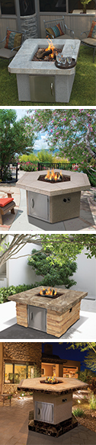 | Releasing New Cal Flame Fire Pit Models for 2018  Pomona, CA — (July 5, 2018) This year Cal Flame has released a Fire Pit Series that will make outdoor living a treat! Say hello to the latest innovation from Cal Flame that will create an atmosphere to make any backyard thrive.  With four models to choose from, you can customize with your choice of Porcelain Tile and Ameristone Stucco finish in 5 different colors and 8 cultured stone styles. Each Fire Pit includes a square firebox, except for the model FPT-RT501M, which is a rectangle curve.  Fire Pits will carry a 4-piece 16” log set with lava rocks. Each burner output comes with 55,000 BTU, powerful enough to be seamless and effective. Including an 18” vertical door you are able to store liquid propane to keep the area safe and organized. Additionally, you can hook the fire pits up to natural gas as an option.  The height of the FPT-H1050T is 45” inches which is relevant to a bar height, including a footrest. The other 3 Cal Flame Fire Pit models are 25” inches, which is relevant to the same size as a coffee table. Therefore, you are able to comfortably enjoy a beverage or appetizers around the fire.  On selected models you are able to add extra features including LED lighting, multi-setting light show or simply program to your favorite single color for any occasion.  About Cal FlameTM  Customers are encouraged to visit their local certified Cal Flame BBQ dealer to find more information about the Premium 6 including pricing, availability and customization. Founded in 2000, Cal Flame is an award-winning hearth and barbecue manufacturer that offers innovative backyard solutions for every home and budget. Cal Flame lineup includes grills, drop-in accessories, customized outdoor kitchens, barbecue islands, custom barbecue carts, fireplaces and fire pits. For more information about Cal Flame, visit www.calflamebbq.com.  To schedule an interview with one of Cal Spas industry professionals contact Public Relations Specialist, Denai Rosen, at 909-620-0586 or email drosen@calspas.com

