NEWS RELEASE
FOR IMMEDIATE RELEASE

MEDIA CONTACT:
Denai Rosen, Public Relations

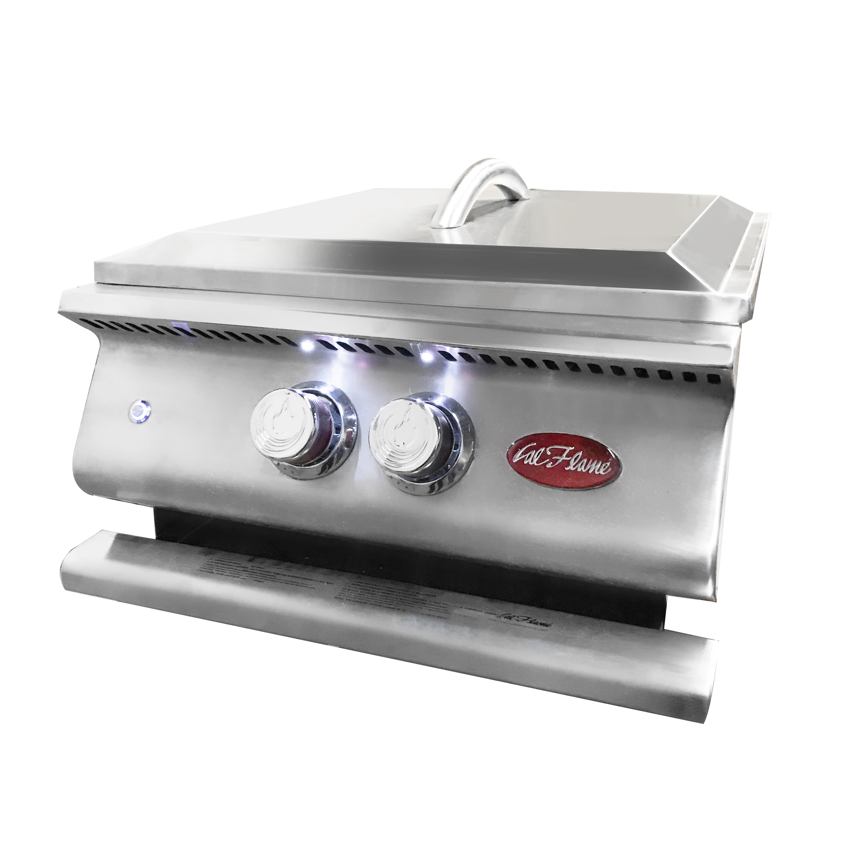  Related Links  Cal Spas Website  Cal Flame Website | New Release - The 2019 Cal Flame Power Burner  Pomona, CA — (October 9, 2018) Cal Flame is extremely proud to announce our Exclusive Built-In Power Burner. The Cal Flame Power Burner is a specialty-cooking surface that is used to cook with a high BTU output ideally for large pots.  The Cal Flame Power Burner has a total of 60,000 BTU. With an external burner (using 35,000 BTU) and an internal burner (with 25,000 BTU). The Exclusive Cal Flame Stainless Steel Knobs come standard with an independent blowtorch ignition system and (2) LED lights on the splashguard to safely see at night. You can turn the LED Lights on with the control on/off switch on the front of the power burner.  The dimensions to the Power Burner is 19” x 21 ½” x 9 ½. The Cal Flame Power Burner and Grill Cover is made with Durable 304-Stainless Steel Construction. The Grill Cover is removable to accommodate large cooking pots. The Grates are heavy-duty with an Exclusive Patented V-Grate design. Additionally, the center is removable to cook with a Wok.  Vented Splash Guards come standard with the Power Burner. Furthermore, for convenience and aesthetics we have added (2) LED Lights under the Vented Splash Guard. The core of the Cal Flame Power Burner funnels down into the full-length drip tray for cleanliness and safety.  The Cal Flame Power Burner is ETL approved and built to last. Adding the Cal Flame Power Burner to a BBQ Kitchen will allow over-all cooking convenience. It is ideal for cooking crab, crawfish, lobster, and wok dishes.  ABOUT CAL FLAME ®  Founded in 2000, Cal Flame is an award-winning hearth and barbecue manufacturer that offers innovative backyard solutions for every home and budget. Cal Flame lineup includes grills, drop-in accessories, customized outdoor kitchens, barbecue islands, custom barbecue carts, fireplaces and fire pits. For more information about Cal Flame, visit www.calflamebbq.com.

