NEWS RELEASE
FOR IMMEDIATE RELEASE

MEDIA CONTACT:
Denai Rosen, Public Relations
press@calspas.com or 1-800-CAL-SPAS

Related Links  Cal Spas Website  Cal Flame Website  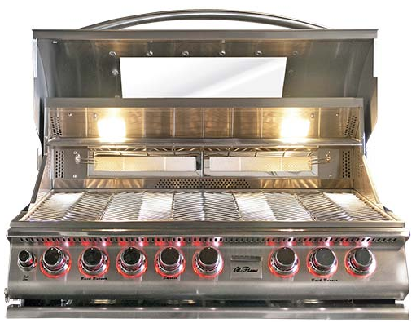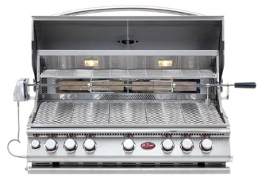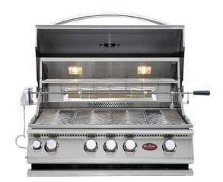 | Bake outside with the Cal Flame Convection Grill  Pomona, CA — (July 16, 2018) An option once only found in the kitchen is now available for the cooking enthusiast outdoors. Convection cooking uses high velocity fans to distribute hot air throughout the entire cavity of the grill when the grill hood is shut.  By circulating hot air, cooking times are greatly reduced and food is cooked evenly. Compared to conventional barbecue grills, cooking with a convection grill offers faster pre-heat times, reduced gas consumption, and increased cooking control.  High velocity fans located at the rear of the grill circulates heated air around and against the food creating an overall ambient temperature. The result of this motion is even baking and delightful textures.  Convection barbecue grills also reduce cooking times up to 30% and use up to 25% less fuel than traditional barbecue grills. By adding convection control to a barbecue grill, grilling enthusiasts can now enjoy the convenience of baking outdoors while grilling their favorite meats, vegetables and poultry at the same time.  Gourmet recipes are ready to serve faster with convection cooking. Made of solid 304-stainless steel, our burners emit up to 95,000 BTU with our 5-burner grill (75,000 BTU – 4-burner grill) and have a ten-year warranty. Cal Flame Convection Grills are also equipped with premium features and added value.  ABOUT CAL FLAME ® Founded in 2000, Cal Flame is an  award-winning hearth and barbecue manufacturer that offers innovative backyard solutions for every home and budget. Cal Flame lineup includes grills, drop-in accessories, customized outdoor kitchens, barbecue islands, custom barbecue carts, fireplaces and fire pits. For more information about Cal Flame, visit www.calflamebbq.com.

