NEWS RELEASE
FOR IMMEDIATE RELEASE

MEDIA CONTACT:
Denai Rosen, Public Relations
press@calspas.com or 1-800-CAL-SPAS
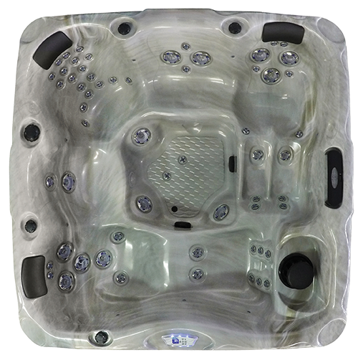  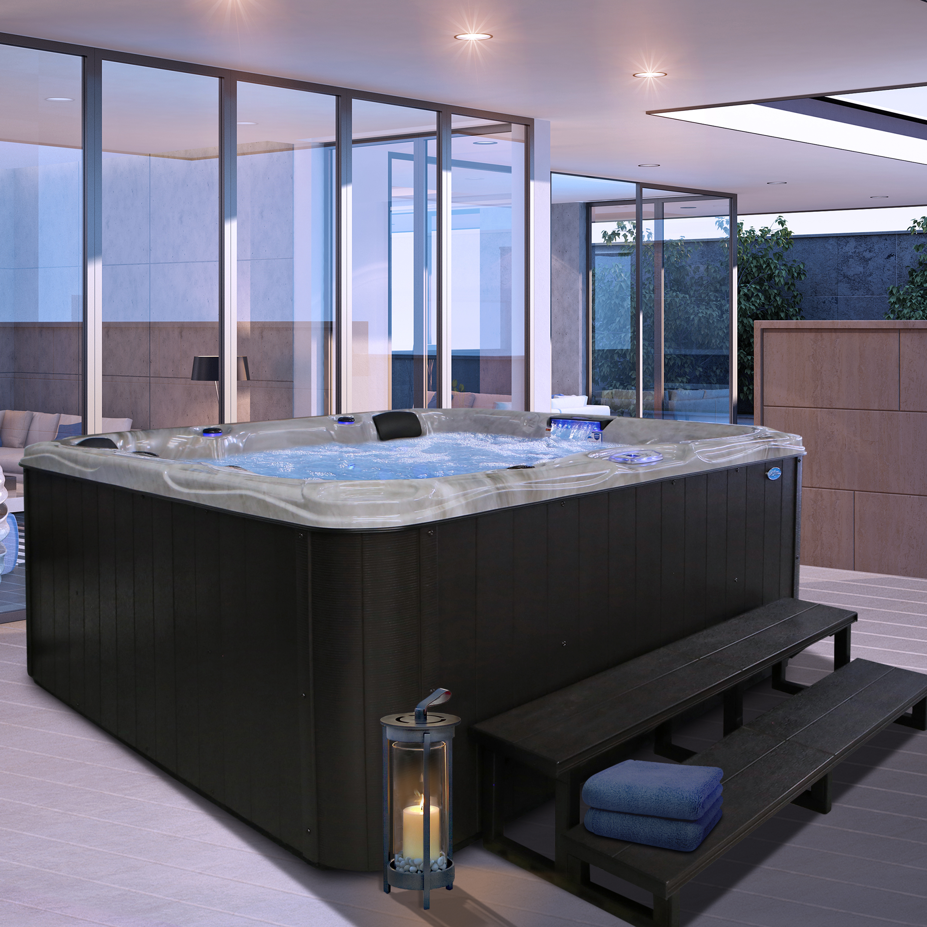  Related Links  Cal Spas Website | Better Together in a ‘His and Hers’ Hot Tub  Pomona, CA — (October 1, 2018) The Escape Malibu EC-754DL is a ‘His and Hers’ spa considering the two loungers are made to fit a woman’s body flawlessly, and a man’s body impeccably. The lounger made for ‘her’ has grooves surrounding the legs; therefore the woman does not float to the top. The lounger made for ‘him’ is broad and built for a masculine body. On both loungers, different jet placement has been strategically placed to accommodate both body types.  The dimensions to the EC-754DL are 87” x 87”x 39 ½”. The Escape 754DL Cal Spas Hot Tub can fit up to 5 people comfortably, with a giant foot well including jets. The EliminatorTM High Performance Pump comes equipped using a 2-pump system of 6.0 BHP with an operating voltage of 240V.  The EC-754DL comes with a powerful, 54 Stainless Steel exclusive VelocityTM Jets, and (3) Y-Pillows for ultimate relaxation. Enhance the evenings with the LED Curved Cascade Waterfall and the Premium LED Lighting Package. Intuitively control the features using the Whisper Power Unit, Neo 1500 System, with full color 1100 Wave Topside Control.  The EC-754DL uses 75 sq. ft. of Bio-CleanTM Filter to maintain clean water, and stays hot using the 5.5kW Titanium WhisperHotTM Heating System. Cal Spas uses Thermo-Shield Insulation, with side panels and thermo-layer floor, with ABS liner to keep the heat contained.  Choose from a selection of deluxe colors for the acrylic shell. Cal Preferred Vertical Cabinet Panels comes in Mahogany, Smoke & Mist. With a spa cover choice of Gray or Slate. The EC-754DL will give the best hydrotherapy experience standard. However, it has optional features are available such as the ATS Plus, AAT, Pure Silk, C-Light, Wifi, and Freedom Sound System.  ABOUT CAL SPAS ®Cal Spas was founded in 1978 as a provider of luxury hot tubs. Today, the celebrated hot tub giant is world renowned as the #1 Global Manufacturer of Home Resort Products™. The company produces premium collections of lifestyle products from its headquarters in Pomona, California and distributes worldwide through a network of specialty dealers. The Cal Spas brand family of products includes Cal Spas hot tubs and swim spas and Cal Flame high-end barbecue grills, outdoor barbecue islands, outdoor fireplaces and fire pits. Learn about Home Resort Living and find a local authorized dealer at www.calspas.com.

