NEWS RELEASE
FOR IMMEDIATE RELEASE

MEDIA CONTACT:
Denai Rosen, Public Relations

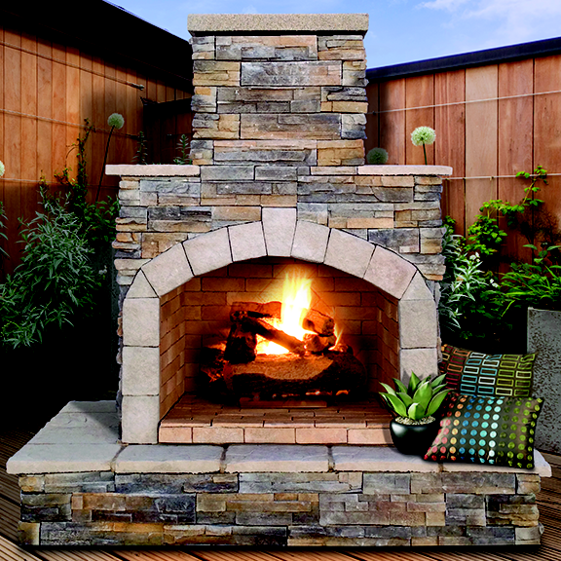  Related Links  Cal Spas Website  Cal Flame Website | Epic Fireplaces Hand Made To Suit Any Backyard Oasis  Pomona, CA — (December 3, 2018) Cal Flame welcomes folks to comfortably unwind in front of a stylish outdoor fireplace in their advantageous living space, no matter the season.  Built to last with a 16-gauge galvanized steel frame, reinforced by Hardbacker Tile backer board, and sturdy one-piece construction.  Finished with the choice of Ameristone Stucco, Cultured Stone,  and Porcelain Tile.  Each Cal Flame Fireplace comes standard with a chimney, and protective cap, that is varies by length and shape depending on the model. The firebox is 36” wide built with stone and bordered with a decorative stone arch. The Stainless Steel burner emits 55,000 BTUs of heat and comes standard with a 7-piece (24”) log set with lava rocks that sit on 18” Grate.  Each Cal Flame Fireplace comes standard with your choice of a mantel. You can choose between no mantel, extended bottom mantel, and wrapped mantel. The back-side of Cal Flame Fireplaces are styled with Ameristone Stucco in the color of your choice.  The Cal Flame Fireplaces uses a battery-powered electronic-ignition with easy to use on/off switch. Light the fireplace with liquid propane or a natural gas option; this eliminates the use of matches or wires.  Match the Cal Flame Fireplace with any Cal Flame product such as a BBQ Island, Firepit, and an Outdoor Entertainment Center to create a divine living space that will impress your guest at each occasion.  _________________________________________________________  ABOUT CAL FLAME ®  Founded in 2000, Cal Flame is an award-winning hearth and barbecue manufacturer that offers innovative backyard solutions for every home and budget. Cal Flame lineup includes grills, drop-in accessories, customized outdoor kitchens, barbecue islands, custom barbecue carts, fireplaces and fire pits. For more information about Cal Flame, visit www.calflamebbq.com.

