NEWS RELEASE
FOR IMMEDIATE RELEASE

MEDIA CONTACT:
Denai Rosen, Public Relations

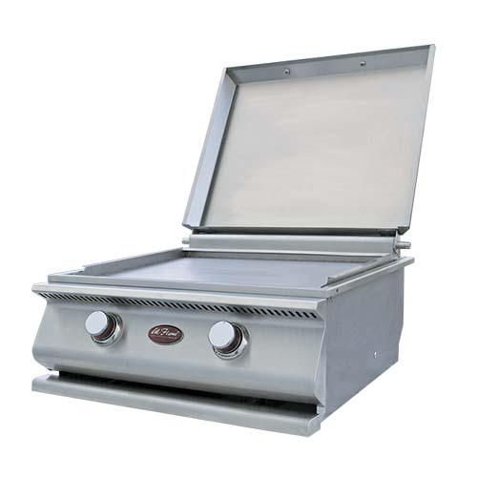  Related Links  Cal Spas Website  Cal Flame Website | Embrace Teppanyaki Cooking with the Hibachi Grill  Pomona, CA — (December 18, 2018) The Hibachi Grill is a flattop gas grill that allows users to embrace Teppanyaki cooking. The Hibachi flattop griddle is made with Double Welded Stainless Steel with the dimensions of 24¼" x 25¼" x 11⅜". The top cover of the Hibachi Grill comes equipped with a one-piece handle.  The Cal Flame Hibachi Grill is fueld by liquid propane and has duel cast iron porcelain coated burners with 15,000 BTUs each. The total output is 30,000 BTUs of cooking power inside the Hibachi Grill.  The oil from the grill is channeled to one drain that conveniently goes straight to the drip pan. Slide out the drip tray on rollers and clean the oil at your convenience. Ultimately, making the Hibachi Grill easy to clean and safe to use.  With the Hibachi Grill, you are getting an independent ignition system. This means you can light the grill effortlessly with out a lighter or a flame getting lost in the wind. The Stainless Steel Splashguard keeps your fingers safe while adjusting the temperature.  The Hibachi Grill is a drop-in accessory that is makes grilling on an Outdoor Luxury BBQ Kitchen a true savory experience. The Hibachi Grill is ideal to cook breakfast foods or stir-fry.  ABOUT CAL FLAME ®  Founded in 2000, Cal Flame is an award-winning hearth and barbecue manufacturer that offers innovative backyard solutions for every home and budget. Cal Flame lineup includes grills, drop-in accessories, customized outdoor kitchens, barbecue islands, custom barbecue carts, fireplaces and fire pits. For more information about Cal Flame, visit www.calflamebbq.com.

