NEWS RELEASE
FOR IMMEDIATE RELEASE

MEDIA CONTACT:
Lauren Roberts, Public Relations
lroberts@calspas.com or 1-800-CAL-SPAS

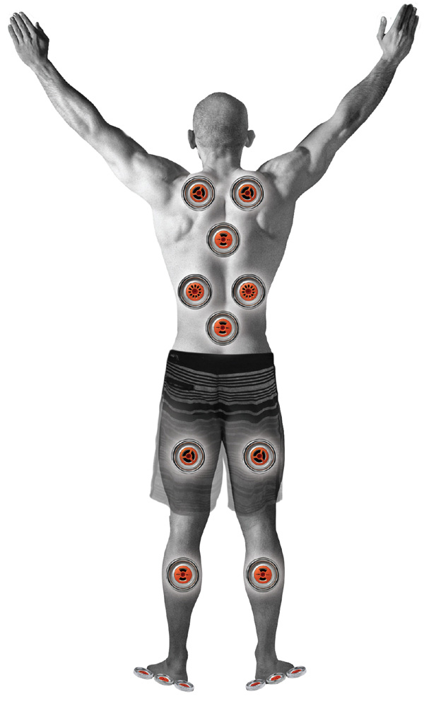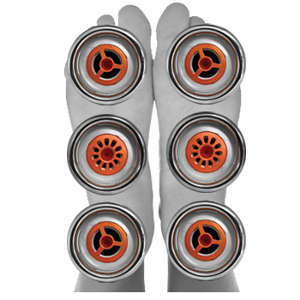 Cal Spas® Provides a Massage Therapy Experience for Sore Muscles  Related Links  Cal Spas Website | Cal Spas® Exclusive: Aquatic Air Therapy Jets™  Cal Spas® Provides a Massage Therapy Experience for Sore Muscles  Pomona, CA — (September 11, 2017) Cal Spas, the leading hot tub and swim spa manufacturer in the United States, proudly offers the Aquatic Air Therapy Jets™ (AAT), a feature exclusive to Cal Spas.  The AAT Jets, in conjunction with the massage ring, provides a massage therapy experience for sore muscles and aching joints. The system, featuring three different types of jets, targets different areas of the body.  The Flex Jet™ delivers a gentle yet strong stream of water to more delicate areas of the body, such as wrists, joints, and extra sensitive muscles.  The Duo Jet™ targets larger parts of the body, including the lower back, legs, and shoulders.  The Precision Jet™ emits the perfect combination of air and water to target specific problem areas, while a soft massage ring provides relief on contact.  The AAT system has its own dedicated Air Control, which allows the user to adjust the air flow precisely to create a total spa therapy experience.  This exclusive feature is available on select areas of spas, and is a complete soft tissue therapy experience perfect for any spa lover.  [more]  For more information about Cal Spas Swim Pro™ Swim & Fitness Spa please visit the Cal Spas website, or locate a certified dealer in your area.  To schedule an interview with one of Cal Spas industry professionals contact Public Relations Specialist, Lauren Roberts, at 909-620-0480 or lroberts@calspas.com.  ABOUT CAL SPAS ®  Cal Spas was founded in 1979 as a provider of luxury hot tubs. Today, the celebrated hot tub giant is world renowned as the #1 Global Manufacturer of Home Resort Products™. The company produces premium collections of lifestyle products from its headquarters in Pomona, California and distributes worldwide through a network of specialty dealers. The Cal Spas brand family of products includes Cal Spas hot tubs and swim spas, Cal Designs gazebos, Cal Heat indoor and outdoor saunas, and Cal Flame high-end barbecue grills, outdoor barbecue islands, outdoor fireplaces and fire pits. Learn about Home Resort Living and find a local authorized dealer at www.calspas.com.

